FORM 2 MIDTERM 2 EXAMS


(SMART-GRADE SERIES)
ALL SUBJECTS

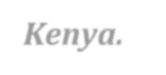
Smart-grade Collection of Standard set of Mid-Term 2 Assessment Tests for the Current Class for all High Schools in the Republic of Kenya.


SUBJECTS TESTED;
Mathematics, English, Kiswahili, Biology, Chemistry, Physics, CRE,
Geography, History, Business Studies, Home-Science & Agriculture.

SMART-GRADE SERIES

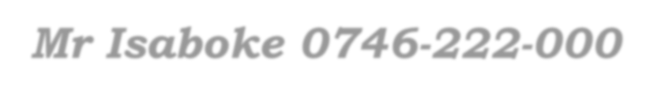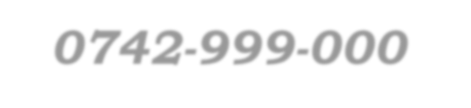
For Marking Schemes / Answers
Mr Isaboke 0746-222-000 / 0742-999-000
MWALIMU CONSULTANCY

FORM 2 MIDTERM 2 EXAMS

SMART-GRADE SERIES
CHRISTIAN RELIGIOUS EDUCATION

TIME: 2½ HOURS

NAME……………………………………………………. ADM NO; …………………..

CLASS……………………………………………………… DATE……………………..

Answer all questions
1 a) Describe the characteristics of the suffering servant of Yahweh as prophesied by prophet Isaiah. (8mks)
- From the story of the annunciation of Jesus birth identify the angel’s message to Mary.
(5mks)
- What kind of Messiah did the Jews expect? (7mks)

- a) Relate Mary’s visit to Elizabeth ( Luke. 1: 39 -45) (6mks)
- Discuss the role of John the Baptist as a link between the Old Testament and the
New Testament (8mks)
- Mention five ways in which Christians prepare for the second coming of Christ. (5mks)

- a) Give seven reason why Jesus accepted to be baptized yet he had no sins. (7mks)
- Describe the healing of the Gerasene demoniac (8mks)
- What are the characteristics of a true follower of Christ? (5mks)

- a) Describe the commissioning of the seventy two disciples (7mks)
- Explain four lessons learnt from commissioning of the twelve disciples. (8mks)
- Give reasons as to why disciples are called today. (5mks)

- a) Narrate the parable of the rich man and Lazarus (Luke 16:19-31) (8mks)
- What is the relevance of the teachings on wealth and poverty to Christians? (7mks)
- Mention the roles Christian have in fighting corruption. (5mks)

#END

FORM 2 MIDTERM 2 EXAMS


SMART-GRADE SERIES
HISTORY AND GOVERNMENT

TIME: 2½ HOURS

NAME……………………………………………………. ADM NO; …………………..

CLASS……………………………………………………… DATE……………………..

HISTORY AND GOVERNMENT TIME: 2 ½ HOURS

FORM 2

INSTRUCTIONS TO CANDIDATES.
- This paper consists of three sections A, B and C.
- Answer all questions in section A, three questions from Sec. B and two questions from section
C.
- Answers to all questions should be written in the answer booklet provided.

 | Section A | Section B |  |  |  | Section C
Question No. | 1-16 | 17 | 18 | 19 | 20 | 21 | 22 | 23
Marks

Grand total

SECTION A(25MARKS)

Answer all questions from this section
- Give two limitations of the evolution theory. (2mk)
- State one economic activity of the early man. (1mk)
- Give two reasons why Africa is the Cradle land of mankind. (2mks)
- Mention two types of irrigation systems used in ancient Egypt. (2mks)
- Give one advantage of the land enclosure system in Britain. (2mks)
- Mention two advantages of the Barter System of Trade. (2mks)
- Name two British engineers involved in the construction of roads on the 18th Century. (2mks)
- State two limitations of cell phones. (2mks)
- Give the main duty of Orkoiyot among the Nandi . (1mk) 10.Mention two reasons why the rulers of Malindi welcomed the Portuguese in the 18th C.(2mks)
11.Name the inventor of the electro dynamo. | (1mk)
12.What was the contribution of Gottlieb Daimler to the development of road transport. | (1mk)
13. State two main sources of energy during the industrial evolution period. | (2mks)
14.Mention two Landmark Monuments left by the Portuguese in East Africa. | (2mks)
15. Name the first Christian Missionary to establish a mission station in Rabai in 1844. | (1mk)
16.State the original homeland of the Bantu speakers. | (1mk)

SECTION B (45MARKS)

Answer any three questions from this section
17.(a) Identify any five uses of gold in Central Africa. (5mks)
(b) Explain five ways in which the skill of iron working spread in Africa (10mks)

18. (a) Mention five factors that facilitated the industrial revolution in Britain around the
18th and the 19th Centuries. (5mks)
(b) Explain any five effects of the Industrial revolution on the European society. (10mks)

19.(a) Identify five factors that facilitated the scientific revolution in Europe. (5mks)
(b) Explain any five negative impacts of the scientific discoveries in the society today. (10mks)

SECTION C (30 MARKS)

Answer any two questions from this section
- (a) Identify three communities that are part of the Eastern Cushites in Kenya. (3mks)
(b) Explain six effects of the Cushitic migration into Kenya. (12mks)

- (a) State five advantages of National Integration. (5mks)
(b) Explain five factors that promote national unity in Kenya. (10mks)

23.(a) Identify three peaceful methods of resolving conflicts in the society today. (3mks)
- Explain five levels of conflicts in the society today. (10mks)

FORM 2 MIDTERM 2 EXAMS


SMART-GRADE SERIES
GEOGRAPHY
TIME: 2¾ HOURS

NAME……………………………………………………. ADM NO; …………………..

CLASS……………………………………………………… DATE……………………..

Answer all questions .

1. (a) Give three branches of physical geography. | (3mks)
(b) State five reasons why we study geography. | (5mks)
2. (a) Give two results of the rotation of the earth. | (2mks)
(b) Explain four reasons why the earth is said to be spherical. | (8mks)
3. (a) Give three types of field work. | (3mks)
(b) You have been asked to carry a field study on the types of rocks around the school;
(i) Give three methods you would use to collect the data. | (3mks)
(ii) State three problems you may encounter during the field study. | (3mks)
4. (a) What are minerals? | (2mks)
(b) (i) Give two types of fossil fuels. | (2mks)
(ii) Explain three economic importance of rocks. | (2mks)
- State two factors which must be considered before exploitation of minerals is
carried out. (2mks)
- (a) What is a photograph. (2mks)
(b) (i) Give two types of aerial photographs. (2mks)
(ii) State four limitations in the use of photographs. (4mks)
- (a) Give four causes of Earth movements . (4mks)
- Briefly describe the theory of continental drift as advanced by A. Wegner. (5mks)
- Give three boundaries associated with plate tectonic theory. (3mks)

- (a) Differentiate between weather and climate. (2mks)
  - (i) Apart from latitudes and Altitudes give two other factors which influence climate
of a place. (2mks)
(ii) Describe how the following influence climate;
- Latitude (3mks)
- Altitude (3mks)
  - (i) Give two examples of anabatic winds. (2mks)
(ii) Describe the characteristics of desert (5mks)

- (a) Give any three types of forests. (3mks)
(b) (i) Give the names of grasslands in the following countries:
- Canada (1mk)
- Argentina (1mk)
- Australia (1mk)
- South Africa (1mk)
(ii) Explain four uses of Savanna vegetation. (8mks)

- (a) (i) Name three types of grasslands. (3mks)
(ii) State three characteristics of tropical hardwood forests. (3mks)
(b) (i) Explain the significance of forest products to Kenya. (6mks)
(ii) What is agroforestry? (1mk)

FORM 2 MIDTERM 2 EXAMS


SMART-GRADE SERIES
BIOLOGY
TIME: 2 HOURS

NAME……………………………………………………. ADM NO; …………………..

CLASS……………………………………………………… DATE……………………..

BIOLOGY (THEORY) TIME: 2 HOURS

INSTRUCTIONS TO CANDIDATES:
- Write your name and your admission number in the spaces provided above.
- Sign and write the date of the examination in the spaces provided above.
- Answer all the questions in the spaces provided.

FOR EXAMINER’S USE ONLY:

QUESTIONS | MAXIMUM SCORE | CADNIDATE’S SCORE
1 – 30 | 100

Answer all the questions
- The scientific name of the cat is Felis catus classify the cat into; (3mks) i) Kingdom………………………………………
ii) Genus…………………………………………
iii) Species…………………………………………

- Define the following branches of biology.
- Ecology (1mk)
………………………………………………………………………………………………………
………………………………………………………………………………………………………

- Anatomy (1mk)
………………………………………………………………………………………………………
………………………………………………………………………………………………………

- State the functions of each of the following organelles.
  - Centrioles (1mk)
………………………………………………………………………………………………………
………………………………………………………………………………………………………
  - Ribosomes (1mk)
………………………………………………………………………………………………………
………………………………………………………………………………………………………

- Name the Kingdom to which each of the following belong.
- Spirogyra (1mk)
………………………………………………………………………………………………………
- Vibrio cholerae (1mk)
………………………………………………………………………………………………………
- Maize (1mk)
………………………………………………………………………………………………………

- The diagram below represents a cell organelle.

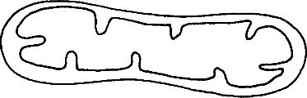N
M

  - Identify the organelle. (1mk)
………………………………………………………………………………………………………
  - Name the part labeled M. (1mk)
………………………………………………………………………………………………………

  - State the function of the part labeled N. (1mk)
………………………………………………………………………………………………………
………………………………………………………………………………………………………

- The organelle below was observed in a cell using a microscope.
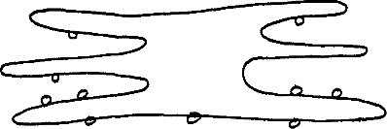

- Identify the organelle above. (1mk)
………………………………………………………………………………………………………
- On the diagram, label the part where protein synthesis occurs. (1mk)

- A form two students trying to estimate the size of onion epidermal cells observed the following on the microscope’s field of view.
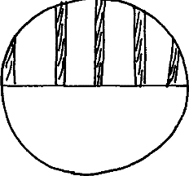

He counted 20 cells across the diameter of the field of view. Calculate the size of one cell in micrometers. (3mks)
………………………………………………………………………………………………………
………………………………………………………………………………………………………
………………………………………………………………………………………………………

- Explain the differences between turgor pressure and wall pressure. (4mks)
………………………………………………………………………………………………………
………………………………………………………………………………………………………
………………………………………………………………………………………………………
………………………………………………………………………………………………………

- Distinguish between haemolysis and plasmolysis (4mks)
………………………………………………………………………………………………………
………………………………………………………………………………………………………
………………………………………………………………………………………………………
………………………………………………………………………………………………………

- The diagram below shows how food moves along the human oesophagus and intestines

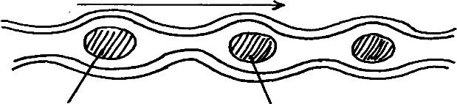Position E₁ Position E₂
Movement

- Identify the process illustrated in the diagram. (1mk)
………………………………………………………………………………………………………
- Explain the movement of the food bolus from position E₁ to position E₂ . (1mk)
………………………………………………………………………………………………………
………………………………………………………………………………………………………
………………………………………………………………………………………………………

- Name one component of the human diet that assist in the movement in (b) above. (1mk)
………………………………………………………………………………………………………

- Below is the structure of an organelle found in a plant.
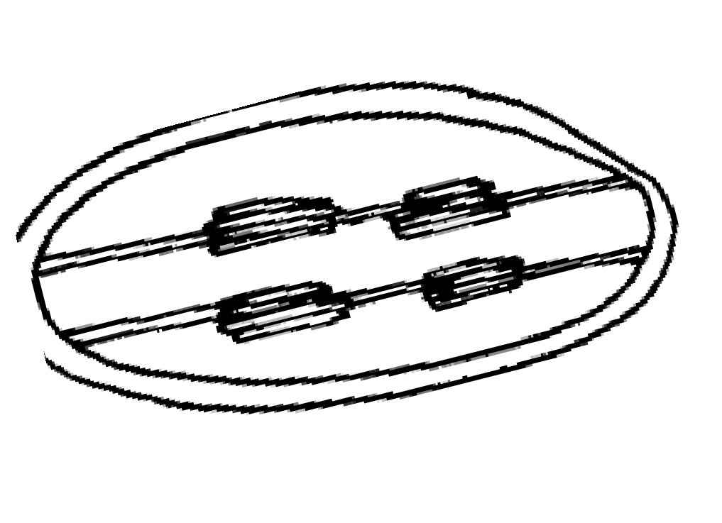
X
- Name the organelle (1mk)
………………………………………………………………………………………………………
- State the functions of the organelle named above. (1mk)
………………………………………………………………………………………………………
………………………………………………………………………………………………………
- Name the part labeled X. (1mk)
………………………………………………………………………………………………………

- Suggest two functions of mucus secreted along the walls of the alimentary canal. (2mks)
………………………………………………………………………………………………………
………………………………………………………………………………………………………

- Name three aspects of light that are important during photosynthesis. (3mks)
………………………………………………………………………………………………………
………………………………………………………………………………………………………
………………………………………………………………………………………………………
- The equation below shows a chemical reaction that takes place in green plants under certain conditions.
Carbon (IV) oxide + Water glucose + X
Name the;
- Substance represented by X (1mk)

- Process represented by the equation (1mk)

15.a) Define the term symbiosis . (1mk)
………………………………………………………………………………………………………
………………………………………………………………………………………………………
b) What are the final products of digestion of fats. (2mks)
………………………………………………………………………………………………………
………………………………………………………………………………………………………

- The diagram below shows a vertical section through amammalian heart.

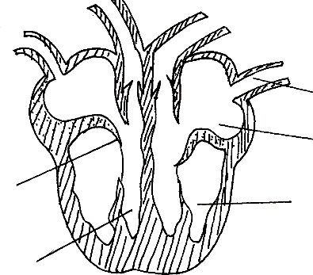A B
E
C
D

  - Name the parts labeled A to E (5mks)
A………………………… C………………………… E…………………………
B ………………………… D…………………………
  - Give a reason why the wall of chamber C is thicker than chamber D. (2mk)
………………………………………………………………………………………………………
………………………………………………………………………………………………………
………………………………………………………………………………………………………
- The figure below represents a transverse section of a young root.

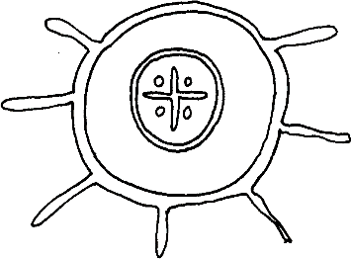A

B

  - Name parts labeled A and B (2mks)
A…………………………………………………………..
B…………………………………………………………..

  - State the functions of parts labeled A and B (2mks) A……………………………………………………………………………………………………
………………………………………………………………………………………………………

B………………………………………………………………………………………………………
………………………………………………………………………………………………………

- List three structural modifications of a leaf which enable plants to reduce water loss. (3mks)
………………………………………………………………………………………………………
………………………………………………………………………………………………………
………………………………………………………………………………………………………
………………………………………………………………………………………………………

- The following schematic diagram represents the main stages in the blood clotting process.
Broken platelets release A

Prothrombin B

C Fibrin
  - Name the Substances A and C. (2mks)
A……………………………………………….
C………………………………………………...

- State two ways in which the leaf is suited to gaseous exchange. (2mks)
………………………………………………………………………………………………………
………………………………………………………………………………………………………
………………………………………………………………………………………………………

- Name two structures for gaseous exchange in amphibians (2mks)
………………………………………………………………………………………………………
………………………………………………………………………………………………………

- The progress that occurs in plants is represented by the equation below:

C₆H₁₂O₆ 2C₂H₅OH + 2CO₂ + Energy.
  - Name the process (1mk)
………………………………………………………………………………………………………
  - State three economic importance of the named process in (a) above. (3mks)
………………………………………………………………………………………………………
………………………………………………………………………………………………………
………………………………………………………………………………………………………

- State one role that is played by osmosis in;
- Plants (1mk)
………………………………………………………………………………………………………
………………………………………………………………………………………………………
- Animals (1mk)
………………………………………………………………………………………………………
………………………………………………………………………………………………………

24.a) State three structural differences between arteries and veins in mammals . (3mks)
………………………………………………………………………………………………………
………………………………………………………………………………………………………
………………………………………………………………………………………………………
………………………………………………………………………………………………………

b) Name a disease that causes thickening and hardening of arteries. (1mk)
………………………………………………………………………………………………………

- Name the deficiency diseases of each of the following nutrients . (7mks)
Vitamin A……………………………………….
Vitamin B………………………………………..
Vitamin B₂……………………………………….
Vitamin C………………………………………..
Vitamin D………………………………………..
Calcium………………………………………….
Iodine…………………………………………....

- Explain how the red blood cells of mammals are adapted for efficient transport of oxygen.
(2mks)
………………………………………………………………………………………………………
………………………………………………………………………………………………………
………………………………………………………………………………………………………

28.a) What is the importance of gaseous exchange in plants. (2mks)
………………………………………………………………………………………………………
………………………………………………………………………………………………………
………………………………………………………………………………………………………

b) Name the three gaseous exchange structures in plants. (3mks)
………………………………………………………………………………………………………
………………………………………………………………………………………………………
………………………………………………………………………………………………………

- What are the respiratory structures in the following organisms. (5mks) i. Mammals…………………………………..
ii. Amoeba…………………………………….
iii. Fish…………………………………………
iv. Tadpoles……………………………………
v. Insects……………………………………..

- The diagram below represents apart of the rib cage.

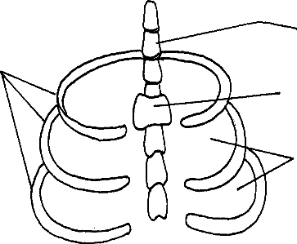W
Y
R

Z

  - Name the bones labeled W,Y and R (3mks)
W……………………………………………….
Y………………………………………………..
R……………………………………………….

  - How does the part labeled Z facilitate breathing in? (3mks)
………………………………………………………………………………………………………
………………………………………………………………………………………………………
………………………………………………………………………………………………………
………………………………………………………………………………………………………

  - State two characteristics of respiratory surfaces. (2mks)
………………………………………………………………………………………………………
………………………………………………………………………………………………………

FORM 2 MIDTERM 2 EXAMS


SMART-GRADE SERIES
CHEMISTRY
TIME: 2 HOURS

NAME……………………………………………………. ADM NO; …………………..

CLASS……………………………………………………… DATE……………………..

233
CHEMISTRY TIME: 2 HOURS

INSTRUCTIONS TO THE CANDIDATES:-
- Answer all the questions in the spaces provided.
- Write your name and admission number, school, date in the spaces provided.
- Mathematical tables and electronic calculators may be used for calculation.
- All workings must be clearly shown where necessary

FOR EXAMINER’S USE ONLY:

Question | Maximum score | Candidate’s score
1-21 | 80

Answer all the questions
- Study the set-up below and answer the questions hat follow;

Bunsen burner flame
Flame

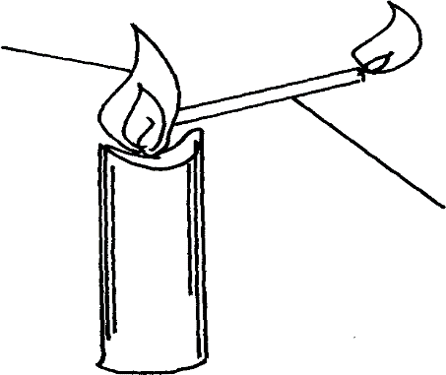
Delivery tube

- What does the experiment demonstrate? (1mk)
………………………………………………………………………………………………………

- When is this type of Bunsen burner flame produced? (1mk)
………………………………………………………………………………………………………

- Give two characteristics of the type of flame used in the set-up (2mks)
………………………………………………………………………………………………………
………………………………………………………………………………………………………

- (a) State the role of the following parts during fractional distillation of a mixture of water and ethanol.
  - fractionating column (1mk)
………………………………………………………………………………………………………

  - Glass beads in the fractionating column (1mk)
………………………………………………………………………………………………………

(b) State any two applications of fractional distillation process. (2mks)
………………………………………………………………………………………………………
………………………………………………………………………………………………………
………………………………………………………………………………………………………

- A certain indicator was added to a solution. The pH value on the scale that was used with this indicator was read as 6.5
- Name the indicator (1mk)
………………………………………………………………………………………………………
- State the nature of the solution (1mk)
………………………………………………………………………………………………………
- Why is the above indicator a better indicator than other common indicators used in
the laboratories? (1mks)
………………………………………………………………………………………………………
………………………………………………………………………………………………………

- A student set-up the experiment below:

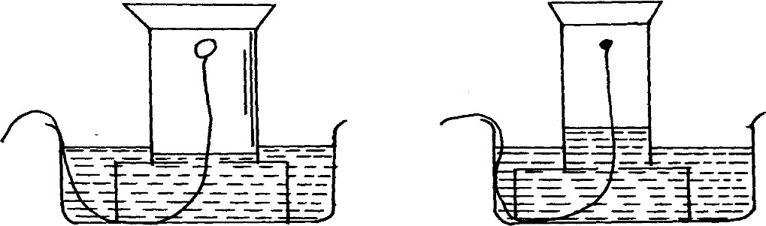
Gas jar
White phosphorous
Gas jar

Start of experiment End of experiment
- What was the aim of the experiment? (1mk)
………………………………………………………………………………………………………

- Give the observations made. (1mk)
………………………………………………………………………………………………………
………………………………………………………………………………………………………

- Write an equation for the reaction that takes place in the gas jar. (1mk)
………………………………………………………………………………………………………
………………………………………………………………………………………………………

- The set-up below was used to prepare the gas and investigate its properties

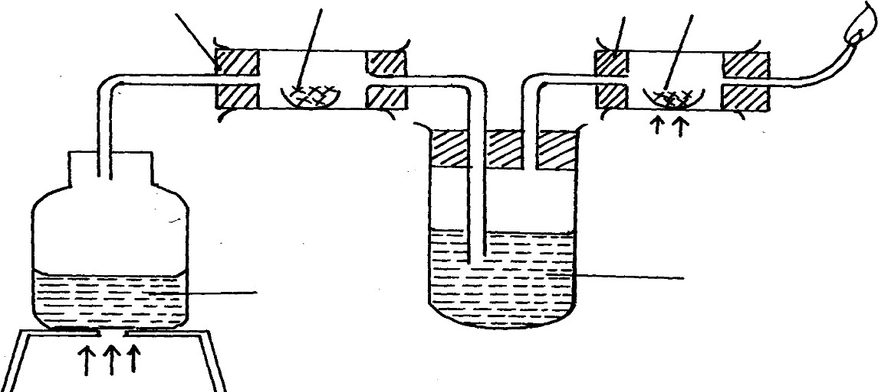Gas burning
A
Magnesium ribbon
B Lead (II) oxide
Heat
Heat
Water
Liquid R

Heat
- Write a chemical equation for the reaction in combustion tube A that leads to the formation of the gas. (1mk)
………………………………………………………………………………………………………
- Identify liquid R. Why is it used? (1mk)
………………………………………………………………………………………………………
- State the observation made at the end of the reaction in combustion tube B. (1mk)
………………………………………………………………………………………………………
………………………………………………………………………………………………………

- A given element E has atomic number of 14 and consists of isotopes as shown below;

Isotope | X | Y | Z
Isotopic mass | 28 | 29 | 30
Percentage abundance | 92.2 | 4.7 | 3.1
- What are isotopes? (1mk)
………………………………………………………………………………………………………
………………………………………………………………………………………………………
- Determine the relative atomic mass of E (2mks)

- State the position of element E in the periodic table (1mk)
………………………………………………………………………………………………………

- Study the information in the table and answer the questions that follow;

Element | Atomic No. | Electronic  arrangement | Boiling point (ºC)
I | 3 |  | 1617
J | 13 |  | 2740
K | 17 |  | -34
L | 18 |  | -187
M | 19 |  | 1033

- Select elements which belong to the same group. (1mk)
………………………………………………………………………………………………………
- Which elements are in the gaseous state at room temperature (25oC). Explain. (2mks)
………………………………………………………………………………………………………
………………………………………………………………………………………………………
………………………………………………………………………………………………………

- Write the;-
  - Formula of the carbonate of the element J. (1mk)
………………………………………………………………………………………………………

  - Chemical equation for the reaction between the most reactive metal and the most reactive non-metal. (1mk)
………………………………………………………………………………………………………
………………………………………………………………………………………………………

- Draw a dot (•) and cross (X) diagram for the compound formed between elements I and K
(2mks)

- (i) Complete the table above by filling in the electronic arrangements of all the elements.(2½mks)
(ii) Identify the chemical family to which element I belongs. (1mk)
………………………………………………………………………………………………………
………………………………………………………………………………………………………
- Which elements form basic oxides? (1½mks)
………………………………………………………………………………………………………
………………………………………………………………………………………………………
- List any two uses of element L. (2mks)
………………………………………………………………………………………………………
………………………………………………………………………………………………………

- A mixture contains the three gases Ethene, Hydrogen and Ammonia;

Gas | Water | Concentrated H₂SO₄ | Concentrated NaOH
Ammonia Hydrogen  Ethene | Very soluble Slightly soluble  Slightly soluble | Very soluble Insoluble  Soluble | Very soluble Insoluble  Insoluble

- Explain how you would obtain a sample of hydrogen gas from a mixture of the three gases.
(3mks)
………………………………………………………………………………………………………
………………………………………………………………………………………………………
………………………………………………………………………………………………………

- Using dot (•) and cross (X) show the bonding in Carbon (II) oxide. (2mks)

- The following table gives some information about the physical properties of substances
S, T,U and V. Use the information to answer the questions that follow;

Substance | M.pt (ºC) | Hardness | Electrical conductivity  in solid state | Electrical conductivity  in molten state
S | High | Hard/brittle | Good | Good
T | High | Hard/brittle | Poor | Poor
U | High | Hard/brittle | Poor | Good
V | Low | Soft | Poor | Poor

- Which of these substances exists as a;
  - Giant covalent structure (1mk)
………………………………………………………………………………………………………
  - Giant metallic structure (1mk)
………………………………………………………………………………………………………
  - Giant ionic structure (1mk)
………………………………………………………………………………………………………

- (i) Why is the melting point of V low? (2mks)
………………………………………………………………………………………………………
………………………………………………………………………………………………………
………………………………………………………………………………………………………

- Why is U a good electrical conductor when in molten state and poor when in solid state?
(2mks)
………………………………………………………………………………………………………
………………………………………………………………………………………………………
………………………………………………………………………………………………………
- (i) Which substance would you recommend for making the cooking pan? Explain (2mks)
………………………………………………………………………………………………………
………………………………………………………………………………………………………
………………………………………………………………………………………………………

- Name the substance that can be used in the laboratory as an electrolyte. (1mk)
………………………………………………………………………………………………………

- Study the structure below and answer the questions that follow;
H +
A
H – N – H
- B
H

Name the bond represented by A and B (2mks)
A…………………………………………………………………………………………………..
B…………………………………………………………………………………………………..

- (a) Name two methods used to prepare soluble salts (2mks)
………………………………………………………………………………………………………
………………………………………………………………………………………………………
(b) (i) Write a chemical equation for the precipitation of Lead Chloride from Lead nitrate
and Sodium chloride. (1mk)
………………………………………………………………………………………………………

(ii) Give an ionic equation for the reaction in (b) above. (1mk)
………………………………………………………………………………………………………
………………………………………………………………………………………………………

- The diagram below represents the electrolysis of molten lead (II) bromide
battery

Solid X

Heat
Gas Y

Molten lead (II) bromide

(a) Name (2mks)
i) Solid X…………………………………………………………….
ii) Gas Y………………………………………………………………

- Write ionic equations for the formation solid x and gas y (2mks) Solid X…………………………………………………………………………………………………..
Gas Y……………………………………………………………………………………………..
- On the diagram show the anode and the cathode (2mks)

(d) Give one precaution to be taken while carrying out the experiment (1mk)
…………………………………………………………………………………………………..

- Give two properties of Carbon (IV) oxide that makes it suitable for use in fire extinguishers
(2mks)
………………………………………………………………………………………………………
………………………………………………………………………………………………………

- Copper (II) chloride solution and Copper metal are both conductors of electricity. Give two
differences in their mode of conduction (2mks)
………………………………………………………………………………………………………
………………………………………………………………………………………………………
………………………………………………………………………………………………………

- Naturally occurring boron exists as two isotopes, boron-10 of 20% and boron-11 B w¹⁰ith a relative abundance of 80%.
5
5
¹⁰ B with a relative abundance

- How many electrons does each atom of boron contain? (½mk)

- How many neutrons does each atom of the most abundant isotope contain? (1mk)

- Draw the electronic structure of the most abundant isotope of boron (2mks)

- Name two halogens. (2mks)
………………………………………………………………………………………………………
………………………………………………………………………………………………………

- Define the following terms;
- Hygroscopy (1mk)
………………………………………………………………………………………………………
………………………………………………………………………………………………………
- Atom (1mk)
………………………………………………………………………………………………………
………………………………………………………………………………………………………

- The flow chart below shows how sodium carbonate is manufactured by the solvary process. Study it and answer the questions that follow;

Solid B
Ca(OH)_{2(aq)}
Chamber III
Gas P
Chamber II
CaCl2(aq)
Filtrate D
Ammoniacal brine
Chamber IV
Solid R
Chamber V
Gas X
Chamber I
Limestone, solid A and Air
Water

(a) Name the | following substances; | (3mks)
(i) Gas P | ……………………………………………………………………………..
(ii) Gas X | ……………………………………………………………………………..
(iii) Solid A | ……………………………………………………………………………..
(iv) Solid B | ……………………………………………………………………………..
(v) Filtrate D ……………………………………………………………………………..
(vi) Solid R ……………………………………………………………………………..

- Write chemical equations for the reactions that occur in;
  - chamber I (1mk)
………………………………………………………………………………………………………

  - Chamber II (1mk)
………………………………………………………………………………………………………

- Name two gases that are recycled in the above process (2mks)
………………………………………………………………………………………………………
………………………………………………………………………………………………………

- Give one use of sodium carbonate (1mk)
………………………………………………………………………………………………………

- The figure below represents part of a periodic table. Study it and answer the questions that follow: (The letters do not represent the actual symbols of the elements)
I VIII
 | II |  | III | IV | V | VI | VII
 | K
P |  |  | M |  |  |  | X
T |  |  |  |  |  |  | A

- What name is given t the group to which P and T belong? (1mk)
………………………………………………………………………………………………………

- Which letters represent non-metallic elements? (2mks)
………………………………………………………………………………………………………
………………………………………………………………………………………………………

- What type of bond is formed when P and X react? Explain (2mks)
………………………………………………………………………………………………………
………………………………………………………………………………………………………
………………………………………………………………………………………………………

- Give the formula of the compound formed when element K and oxygen react. (1mk)
………………………………………………………………………………………………………

- On the grid indicate with a tick the position of element Q that is in the second period of
the periodic table and form Q²⁻ ion. (1mk)
- Write the formula of the oxide of M (1mk)
………………………………………………………………………………………………………

- The table below shows the products formed when nitrates of three metals were heated;

Nitrate | Products
U | Metal , Nitrogen (IV) oxide, Oxygen
V | Metal nitrite, Oxygen
W | Metal oxide, Nitrogen (IV) oxide, Oxygen

- Arrange the metals in order of increasing reactivity starting with the least reactive (1mk)
………………………………………………………………………………………………………
- Give the formulae of two possible cations likely to be in Nitrate V (2mks)
………………………………………………………………………………………………………
………………………………………………………………………………………………………

- A student set-up the apparatus shown below to prepare a few jars of dry Carbon (IV) oxide;
H2SO4(aq)
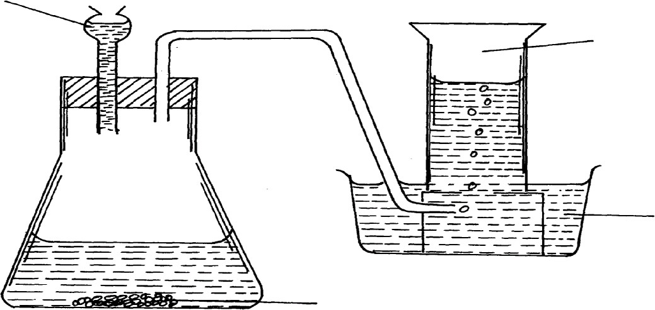
Carbon (IV) oxide

Water

Lead (II) cabornate

- (i) Identify any three mistakes in the set-up (3mks)
………………………………………………………………………………………………………
………………………………………………………………………………………………………
………………………………………………………………………………………………………

(ii) Write a chemical equation for the reaction above. (1mk)
………………………………………………………………………………………………………
………………………………………………………………………………………………………

- Explain the observation made when burning magnesium ribbon is lowered into a gas
jar containing dry carbon (IV) oxide (3mks)
………………………………………………………………………………………………………
………………………………………………………………………………………………………
………………………………………………………………………………………………………
………………………………………………………………………………………………………

FORM 2 MIDTERM 2 EXAMS


SMART-GRADE SERIES
PHYSICS
TIME: 2 HOURS

NAME……………………………………………………. ADM NO; …………………..

CLASS……………………………………………………… DATE……………………..

INSTRUCTIONS TO CANDIDATES:
- Write your name, admission number, date of examination and the name of your school in the spaces provided above.
- Sign and write the date of examination in the spaces provided above.
- This paper consists of sections: A and B.
- Answer all the questions in section A and B in the spaces provided.
- All working must be clearly shown in the spaces provided.
- Mathematical tables and electronic calculators may be used.

For Examiner’s Use Only

SECTION | QUESTION | MAXIMUM SCORE | CANDIDATE’S SCORE
A | 1 – 12 | 25
B | 13
 | 14
 | 15
 | 16
 | 17
 | 18
TOTAL SCORE |  | 80

SECTION A (25MARKS)

Answer all question this section
- Distinguish between mass and weight of a body stating the S.I units for each. (2mks)
………………………………………………………………………………………………………
………………………………………………………………………………………………………
………………………………………………………………………………………………………

- The figure below shows part of scale of vernier calipers.

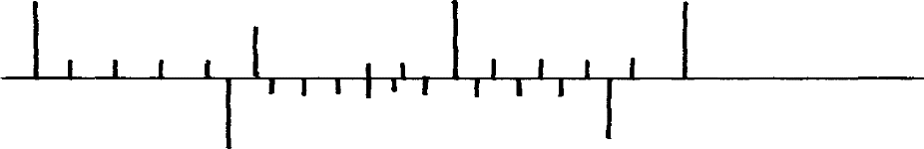0 10
7cm
8cm
What is the reading indicated on the scale (1mk)
- 180cm3 of fresh water of density 100kg/m3 is mixed with 2200cm3 of sea water of density 1025kg/m3. Calculate the density of the mixture (4mks)

- Explain why fish can survive under water when the surface is already frozen (2mks)
………………………………………………………………………………………………………
………………………………………………………………………………………………………
………………………………………………………………………………………………………

- Two inflated balloons are at the same level while suspended from threads a short distance apart as shown below;
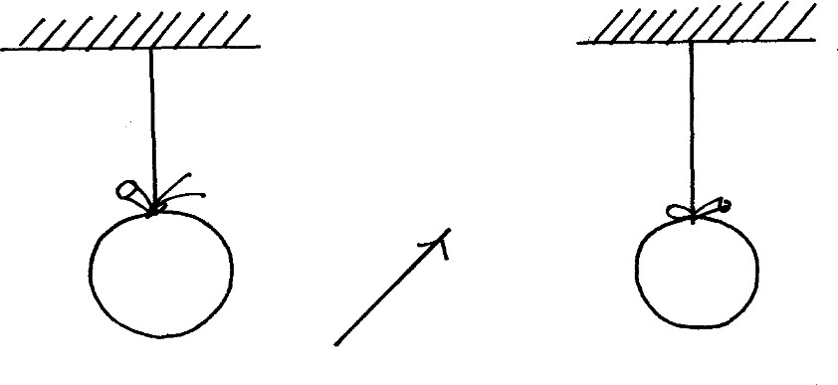
Air blown

Some air is blown gently in the space between the balloon in horizontal direction. Explain
what happens to the balloons. (2mks)
………………………………………………………………………………………………………
………………………………………………………………………………………………………
………………………………………………………………………………………………………

- State one advantage of an alkaline battery over a lead acid battery. (1mk)
………………………………………………………………………………………………………
………………………………………………………………………………………………………

- The diagram below shows a permanent magnet suspended by a spring. State with reason the behaviour of the magnet when the switch is closed. (2mks)

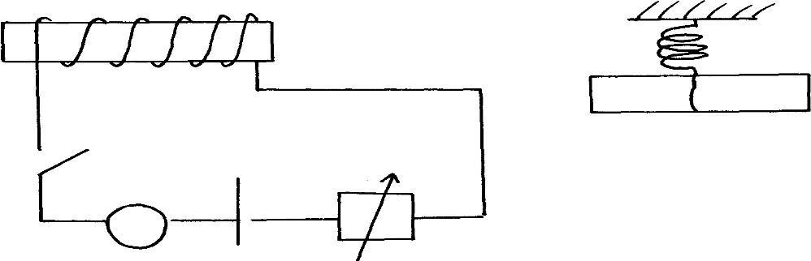
X
Y
N
Spring
S
S
+ -
A
………………………………………………………………………………………………………
………………………………………………………………………………………………………

- Convection and diffusion both involve motion of fluids. Distinguish between the two. (2mks)
………………………………………………………………………………………………………
………………………………………………………………………………………………………
………………………………………………………………………………………………………

- A negatively, charged rod is brought close to (but not touching ) an uncharged sphere. If the sphere is momentarily earthed and then the rod is removed, briefly explain what happens. (2mks)
………………………………………………………………………………………………………
………………………………………………………………………………………………………
………………………………………………………………………………………………………

- Indicate on the diagram below, the level of mercury in the tubes X and Y (2mks)

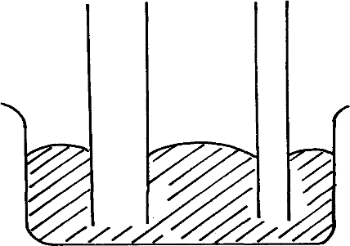Mercury
X
Y

- An object weighs 1200N on a certain planet. What is the gravitational field strength of this planet if the object is 60kg? (3mks)

- State two properties of a thermometric liquid. (2mks)
………………………………………………………………………………………………………
………………………………………………………………………………………………………

SECTION B (55MARKS)

Answer all question this section
- (a) How does amplitude affect the loudness of musical note? (1mk)
………………………………………………………………………………………………………
………………………………………………………………………………………………………
- What can be done to reduce echo in theatre halls? (1mk)
………………………………………………………………………………………………………
………………………………………………………………………………………………………
- A girl stands some distance from a high wall and claps her hands;
  - What two measurements would need to be made in order to determine the speed of sound?
(2mks)

- Describe how you would make use of these measurements. (3mks)
………………………………………………………………………………………………………
………………………………………………………………………………………………………
………………………………………………………………………………………………………
………………………………………………………………………………………………………
………………………………………………………………………………………………………

- A girl is standing between two cliffs A and B but nearer to cliff B than A. She stands 140m from wall B and shouts once. She hears two echoes and discovers that the time between the two echoes is 0.6seconds. Determine how far the girls if standing from the
cliff given that the speed of sound in air is 340m/s. (3mks)

- (a) State Hooke’s law . (1mk)
………………………………………………………………………………………………………
………………………………………………………………………………………………………

(b) The following readings were obtained when a spring was loaded gradually;

Load (N) | 0 | 10 | 20 | 30 | 40 | 50 | 60 | 70 | 80
Extension (cm) | 0 | 12 | 25 | 37 | 48 | 60 | 70 | 78 | 85

- Plot a graph of load (N) against extension (cm) (5mks)



- Mark on your graph the elastic limit P. (1mk)
- Determine from the graph the elasticity constant of the material of the wire. (3mks)

- (a) Distinguish between streamline and turbulent flow. (2mks)
………………………………………………………………………………………………………

- The figure below shows two light sheets of paper arranged as shown;
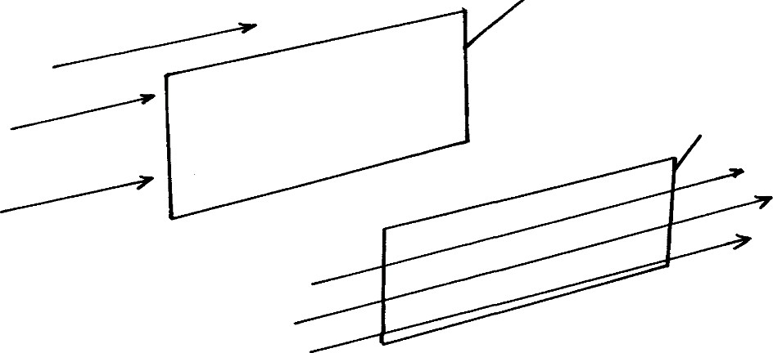Paper
Paper
A
B

Explain the observation made when air is blown at the same speed and at the same time
at point A and B. (2mks)
………………………………………………………………………………………………………
………………………………………………………………………………………………………
………………………………………………………………………………………………………

- The diagram below shows an incompressible fluid moving through a tube of varied cross-sectional area. If the area of the small tube is 0.055m2, calculate the diameter
of the layer tube. (3mks)
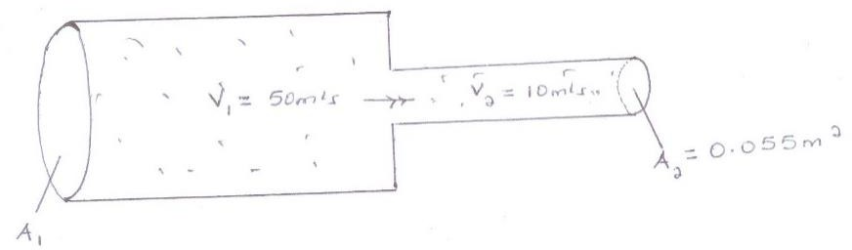
V1 = 50m/s
V2 = 10m/s
A2= 0.055m²

- Explain why a high speed jet has a sharp –nose shape (2mks)
………………………………………………………………………………………………………
………………………………………………………………………………………………………
………………………………………………………………………………………………………

- (a) Define pressure and give its S.I nits. (2mks)
………………………………………………………………………………………………………
………………………………………………………………………………………………………
………………………………………………………………………………………………………

- 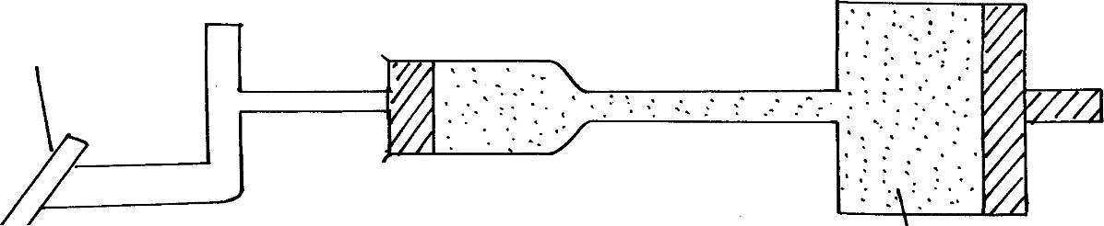The diagram below represents a motor car hydraulic braking system; B
Brake pedal
A
Master piston

Slave piston brake fluid
- State two properties of the liquid used as a brake fluid (2mks)
………………………………………………………………………………………………………
………………………………………………………………………………………………………

- Given that in the diagram (b) above the master piston has an area of 15cm2 and the slave piston has an area of 50cm2 a force of 100N is applied on the master piston. Find the force used to stop the car. (3mks)

- Compare the values of pressure in the two pistons above and give a reason for your answer. (2mks)
………………………………………………………………………………………………………
………………………………………………………………………………………………………
………………………………………………………………………………………………………

- Give a reason why gas is not suitable for use in place of the brake fluid. (1mk)

- (a) Define centre of gravity. (1mk)
………………………………………………………………………………………………………
………………………………………………………………………………………………………

- State two factors affecting stability of a book. (2mks)
………………………………………………………………………………………………………
………………………………………………………………………………………………………

- Use simple sketches to show the three states of equilibrium. Name the states. (3mks)

- (a) Distinguish between a longitudinal wave and a transverse wave. (1mk)
………………………………………………………………………………………………………
………………………………………………………………………………………………………

- The figure below shows a displacement time graph of a wave. The velocity of the wave is 0.4m/s
0.4

0.2
0
0.05 0.10 0.15 0.20 0.25
-0.2
0.30
Time (S)
-0.4
Displacement (m)

Determine;
- The amplitude (1mk)
………………………………………………………………………………………………………
………………………………………………………………………………………………………

- The period (1mk)
………………………………………………………………………………………………………
………………………………………………………………………………………………………
………………………………………………………………………………………………………

- The wavelength (2mks)
………………………………………………………………………………………………………
………………………………………………………………………………………………………
………………………………………………………………………………………………………

- State one disadvantage of a convex mirror when used as a car driving mirror (1mk)
………………………………………………………………………………………………………
………………………………………………………………………………………………………

- What property of light is suggested by the formation of shadows? (1mk)
………………………………………………………………………………………………………
………………………………………………………………………………………………………

FORM 2 MIDTERM 2 EXAMS


SMART-GRADE SERIES
AGRICULTURE
TIME: 2 HOURS

NAME……………………………………………………. ADM NO; …………………..

CLASS……………………………………………………… DATE……………………..

Answers all questions in the spaces provided.
- What determines the colour of a particular soil? (1mk)
………………………………………………………………………………………………………

- Give three reasons why soil is important in crop production. (3mks)
………………………………………………………………………………………………………
………………………………………………………………………………………………………
………………………………………………………………………………………………………

- State four physical agents of weathering. (4mks)
………………………………………………………………………………………………………
………………………………………………………………………………………………………
………………………………………………………………………………………………………
………………………………………………………………………………………………………

- List four tools used for laying concrete blocks when constructing a wall. (4mks)
………………………………………………………………………………………………………
………………………………………………………………………………………………………
………………………………………………………………………………………………………
………………………………………………………………………………………………………

- Differentiate between the following :-
  - Seeded and seedling bed. (2mk)
………………………………………………………………………………………………………
………………………………………………………………………………………………………
………………………………………………………………………………………………………
  - Tilt and tillage. (2mks)
………………………………………………………………………………………………………
………………………………………………………………………………………………………
………………………………………………………………………………………………………

- State four climatic factors that influence crop production. (4mks)
………………………………………………………………………………………………………
………………………………………………………………………………………………………
………………………………………………………………………………………………………
………………………………………………………………………………………………………

- Name four types of water pumps. (4mks)
………………………………………………………………………………………………………
………………………………………………………………………………………………………
………………………………………………………………………………………………………
………………………………………………………………………………………………………

- Name two breeds of dairy goats kept in Kenya. (2mks)
………………………………………………………………………………………………………
………………………………………………………………………………………………………

- List down at least five characteristics of a typical beef cattle. (5mks)
………………………………………………………………………………………………………
………………………………………………………………………………………………………
………………………………………………………………………………………………………
………………………………………………………………………………………………………

- a) Identify the tools labeled A,B,C and D (2mks)
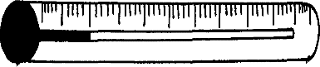
A
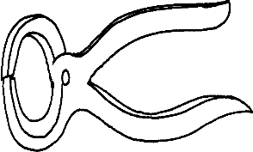
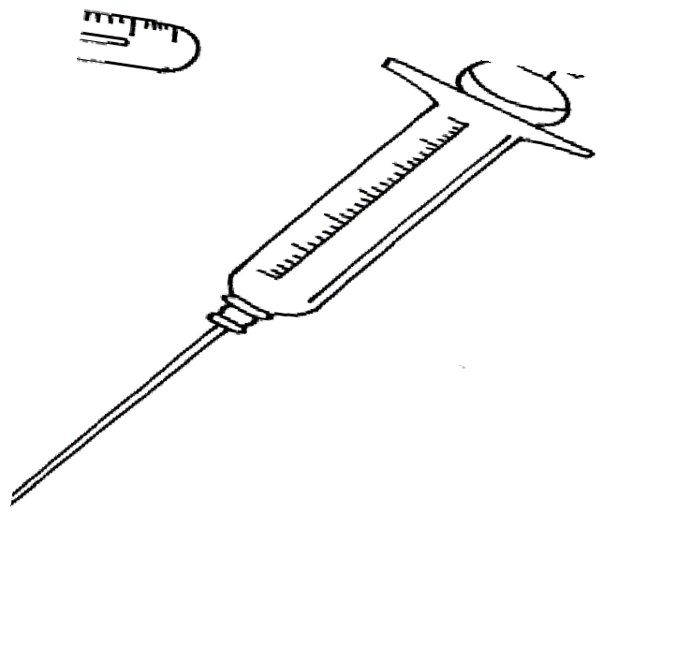C

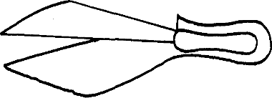

D
B
- Give one use of each of the tools illustrated in (a) above. 2mks)
………………………………………………………………………………………………………
………………………………………………………………………………………………………
………………………………………………………………………………………………………
………………………………………………………………………………………………………

- Name the part of the animal where specimen A is placed when in use. (1mk)
………………………………………………………………………………………………………

- State three features of a good maize granary. (3mks)
………………………………………………………………………………………………………
………………………………………………………………………………………………………
………………………………………………………………………………………………………

- Give four advantages of mulches on crops. (4mks)
………………………………………………………………………………………………………
………………………………………………………………………………………………………
………………………………………………………………………………………………………
………………………………………………………………………………………………………

- Mention four reasons for carrying out testing of a soil sample. (4mks)
………………………………………………………………………………………………………
………………………………………………………………………………………………………
………………………………………………………………………………………………………
………………………………………………………………………………………………………

- State any four post – harvest practices. (4mks)
………………………………………………………………………………………………………
………………………………………………………………………………………………………
………………………………………………………………………………………………………
………………………………………………………………………………………………………

- i) What is parasitism? (1mk)
………………………………………………………………………………………………………
………………………………………………………………………………………………………
ii) State four effects of parasites on livestock animals. (4mks)
………………………………………………………………………………………………………
………………………………………………………………………………………………………
………………………………………………………………………………………………………
………………………………………………………………………………………………………

- Name two categories of plant nutrients. (2mks)
………………………………………………………………………………………………………
………………………………………………………………………………………………………

- Mention four roles of nitrogen in plants. (4mks)
………………………………………………………………………………………………………
………………………………………………………………………………………………………
………………………………………………………………………………………………………
………………………………………………………………………………………………………

- The diagram labeled E below shows a kale seedling attacked by a pest.

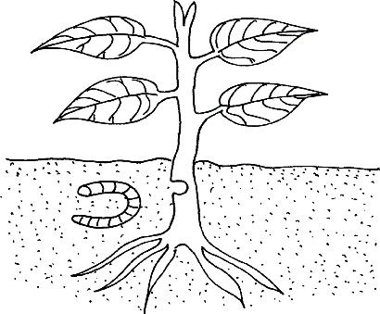
E
- Identify the pest. (1mk)
………………………………………………………………………………………………………
- What damage does the pest cause to the crop? (1mk)
………………………………………………………………………………………………………
- State one method of controlling the pest. (1mk)
………………………………………………………………………………………………………

- State the importance of using certified seeds for planting. (4mks)
………………………………………………………………………………………………………
………………………………………………………………………………………………………
………………………………………………………………………………………………………
………………………………………………………………………………………………………

- State four factors considered in determining the depth of planting. (4mks)
………………………………………………………………………………………………………
………………………………………………………………………………………………………
………………………………………………………………………………………………………
………………………………………………………………………………………………………

- The diagram below shows a soil sampling method.
3
4
6
7
5
8
2
1
10
9
13
14
12 11
- Identity the method. (1mk)
………………………………………………………………………………………………………

- State four activities that are carried out during soil sampling in the field. (4mks)
………………………………………………………………………………………………………
………………………………………………………………………………………………………
………………………………………………………………………………………………………
………………………………………………………………………………………………………

- What information should the sample have before being taken to the laboratory. (3mks)
………………………………………………………………………………………………………
………………………………………………………………………………………………………
………………………………………………………………………………………………………
………………………………………………………………………………………………………

- Outline two positive effects of wind on crop production. (2mks)
………………………………………………………………………………………………………
………………………………………………………………………………………………………

- State four agricultural practices that pollute water. (4mks)
………………………………………………………………………………………………………
………………………………………………………………………………………………………
………………………………………………………………………………………………………
………………………………………………………………………………………………………

- Mention any four methods used in draining land during land reclamation. (4mks)
………………………………………………………………………………………………………
………………………………………………………………………………………………………
………………………………………………………………………………………………………
………………………………………………………………………………………………………

- i) What is opportunity cost? (1mk)
………………………………………………………………………………………………………
………………………………………………………………………………………………………

ii) State four types of farm records. (4mks)
………………………………………………………………………………………………………
………………………………………………………………………………………………………
………………………………………………………………………………………………………
………………………………………………………………………………………………………

- Outline four factors that affect rooting of cuttings. (4mks)
………………………………………………………………………………………………………
………………………………………………………………………………………………………
………………………………………………………………………………………………………
………………………………………………………………………………………………………

FORM 2 MIDTERM 2 EXAMS


SMART-GRADE SERIES
BUSINESS STUDIES
TIME: 2 HOURS

NAME……………………………………………………. ADM NO; …………………..

CLASS……………………………………………………… DATE……………………..

565
BUSINESS STUDIES TIME: 2 ½ HOURS

INSTRUCTIONS TO CANDIDATES:
- Write your name and admission Number in the spaces provided.
- Answer all the questions in the spaces provided.

For Examiner’s Use Only

QUESTION | 1 | 2 | 3 | 4 | 5 | 6 | 7 | 8 | 9 | 10 | 11 | 12 | 13 | 14
MARKS

QUESTION | 15 | 16 | 17 | 18 | 19 | 20 | 21 | 22 | 23 | 24 | 25
MARKS

TOTAL MARKS

Answer all the questions
- Outline four man reasons why business enterprise exists. (4mks)
………………………………………………………………………………………………………
………………………………………………………………………………………………………
………………………………………………………………………………………………………
………………………………………………………………………………………………………

- Highlight four benefits that a community should derive from a manufacturing firm. (4mks)
………………………………………………………………………………………………………
………………………………………………………………………………………………………
………………………………………………………………………………………………………
………………………………………………………………………………………………………

- Outline four measures to be taken by a business man to improve internal business environment.
(4mks)
………………………………………………………………………………………………………
………………………………………………………………………………………………………
………………………………………………………………………………………………………
………………………………………………………………………………………………………

- State four ways in which HIV/AIDS prevalence has negatively affected business activities.(4mk
………………………………………………………………………………………………………
………………………………………………………………………………………………………
………………………………………………………………………………………………………
………………………………………………………………………………………………………

- Outline four difficulties faced by a consumer in the process of satisfying his/her wants. (4mks)
………………………………………………………………………………………………………
………………………………………………………………………………………………………
………………………………………………………………………………………………………
………………………………………………………………………………………………………

- State four reasons why choice is important in the satisfaction of human wants. (4mks)
………………………………………………………………………………………………………
………………………………………………………………………………………………………
………………………………………………………………………………………………………
………………………………………………………………………………………………………
………………………………………………………………………………………………………

- Indicate in the spaces provided the type of utility created by each of the following activities.
(4mks)

 | Activity | Type of utility
(a) | Carpentry
(b) | Shop-keeping
(c) | Teaching
(d) | Importing

- Give any four reasons why occupational mobility of skilled labour is low. (4mks)
………………………………………………………………………………………………………
………………………………………………………………………………………………………
………………………………………………………………………………………………………
………………………………………………………………………………………………………
………………………………………………………………………………………………………

- State four circumstances under which an entrepreneur may want to change his or her business.
(4mks)
………………………………………………………………………………………………………
………………………………………………………………………………………………………
………………………………………………………………………………………………………
………………………………………………………………………………………………………
………………………………………………………………………………………………………

- Explain four measures that the government can take to enhance entrepreneurial culture
in Kenya. (4mks)
………………………………………………………………………………………………………
………………………………………………………………………………………………………
………………………………………………………………………………………………………
………………………………………………………………………………………………………
………………………………………………………………………………………………………
………………………………………………………………………………………………………

- Identify the office equipment used to perform the following tasks: (4mks)

 | Role | Office equipment
(a) | Removing pins form papers
(b) | Printing postage impression on envelopes
(c) | Transmitting printed messages e.g. maps
(d) | Posting information to ledgers and preparation of payrolls

- State four ways in which a well planned office layout contributed towards efficiency of operation in an organization. (4mks)
………………………………………………………………………………………………………
………………………………………………………………………………………………………
………………………………………………………………………………………………………
………………………………………………………………………………………………………

- Give four differences between an invoice and a proforma invoice. (4mks)

Invoice | Proforma Invoice

- Credit cards are increasingly being used in transactions in Kenya. Highlight four disadvantages of using credit cards. (4mks)
………………………………………………………………………………………………………
………………………………………………………………………………………………………
………………………………………………………………………………………………………
………………………………………………………………………………………………………

- Give any four reasons for privatization of government owned firms. (4mks)
………………………………………………………………………………………………………
………………………………………………………………………………………………………
………………………………………………………………………………………………………
………………………………………………………………………………………………………

- Distinguish between a share and a debenture as a source of finance for a public limited company
Share | Debenture
(i) | (i)
(ii) | (ii)
(iii) | (iii)
(iv) | (iv)

- State four factors that limit effectiveness of consumer organization in protecting consumers in Kenya. (4mks)
………………………………………………………………………………………………………
………………………………………………………………………………………………………
………………………………………………………………………………………………………
………………………………………………………………………………………………………

- Give four benefits of Export processing zones to Kenya. (4mks)
………………………………………………………………………………………………………
………………………………………………………………………………………………………
………………………………………………………………………………………………………
………………………………………………………………………………………………………
………………………………………………………………………………………………………

- State four roles played by Kenya ports Authority in ensuring that sea transport operates Efficiently (4mks)
………………………………………………………………………………………………………
………………………………………………………………………………………………………
………………………………………………………………………………………………………
………………………………………………………………………………………………………
………………………………………………………………………………………………………

- Highlight four reasons why the motorbikes are quickly replacing bicycles as a choice
for client (4mks)
………………………………………………………………………………………………………
………………………………………………………………………………………………………
………………………………………………………………………………………………………
………………………………………………………………………………………………………
………………………………………………………………………………………………………

- State four reasons why courier services are becoming popular in the delivery of letters and parcels
………………………………………………………………………………………………………
………………………………………………………………………………………………………
………………………………………………………………………………………………………
………………………………………………………………………………………………………
………………………………………………………………………………………………………

- Despite the remarkable sift to mobile phone system, landlines are still in use. State four
reasons why organizations are still using landline communication. (4mks)
………………………………………………………………………………………………………
………………………………………………………………………………………………………
………………………………………………………………………………………………………
………………………………………………………………………………………………………
………………………………………………………………………………………………………

- Highlight four features of a bonded warehouse. (4mks)
………………………………………………………………………………………………………
………………………………………………………………………………………………………
………………………………………………………………………………………………………
………………………………………………………………………………………………………

- State four measures that the owner of a warehouse may take to ensure its smooth operation.
(4mks)
………………………………………………………………………………………………………
………………………………………………………………………………………………………
………………………………………………………………………………………………………
………………………………………………………………………………………………………
………………………………………………………………………………………………………

- Outline any four benefits of “Pooling of risks” to insurance Company. (4mks)
………………………………………………………………………………………………………
………………………………………………………………………………………………………
………………………………………………………………………………………………………
………………………………………………………………………………………………………

FORM 2 MIDTERM 2 EXAMS


SMART-GRADE SERIES
ENGLISH
TIME: 2 HOURS

NAME……………………………………………………. ADM NO; …………………..

CLASS……………………………………………………… DATE……………………..

101

ENGLISH

TIME: 2 HOURS

INSTRUCTIONS TO CANDIDATES:-
- Write your name, admission number and the name of your school in the spaces provided above.
- Sign and write the date of examination in the spaces provided above.
- Answer all questions in this question paper.
- Answers to all questions must be written in the spaces provided in this booklet.

FOR EXAMINER’S USE ONLY

QUESTION | MAXIMUM  SCORE | CANDIDATE’S SCORE
TOTAL SCORE

Read the passage below and answer the questions that follow. Keep to the information in the passage
Amadu Bah sat on a stool in the cramped front section of the tiny shed that served as his home and place of business. The front part, which opened directly onto the busy road a few feet away, was his shop and the shop was no more than the four feet deep by six feet wide, the range of goods on display was impressive. Amadu Bah, however, was unhappy, business had not been particularly good lately. On top of that, his wife had just given birth to twins, something he had not bargained for. It meant two extra mouths to feed rather than one, in addition to the four small children they already had and his younger brother, just arrived from Jollof. It was a heavy responsibility. And space! Space was really becoming a problem in the room at the back. He mulled over the question on how to raise additional income from his business. When he increased his prices his customers became annoyed and some refused to buy. If he kept his prices low, he made very little money on the things he sold. Only recently he had been forced to raise prices because his Syrian suppliers had started charging more.

Ah! It was a troublesome matter. He felt hot and uncomfortable. It was well into the dry season, and the tin walls of his shop seemed to magnify the sun’s heat despite the open store front. In the back one of the new arrivals was screaming lustily. Just in front of the shop two of his other children were playing to a narrow strip of dirt separated from the road by a shallow gutter.

Three small boys, each about eleven or twelve, came up on the shop and asked for a loaf of bread and a tin of sardines. He told them his new prices and they pulled back, digging in vain in their pockets for extra money. They started calling his names. They began dancing around the front of the shop, just out of his reach, clapping their hands and yelling insults.

“Foulahman, go home, go home’ they sang in delighted unison.
Amadu Bah was enraged. These brats were disrespectful towards him, trying to humiliate hum, when he was doing nothing but struggle to make a living. They would never cheek their Siangan elders like that. Why were they doing to him? Did they think because he was a Foulah they were better than him?

He sat still and unblinking, outwardly oblivious to the boy’s chants. Growing bold, one of them ventured a little too close to the counter. Bah swooped, catching him by the arm as he turned to run. The boy began to scream. Bah jumped over the counter and delivered a sharp slap to his face followed quickly by two heavy blows to the back. Then as he let go of him, he landed a parting shot to the boy’s back to speed him on his way. Unfortunately, this last was powerful enough to cause the boy to lose his balance.

He fell forward into the gutter, hitting his forehead on the sharp concrete edge. Blood spurted out of a nasty gash just below the hair line and the boy lay motionless, his body crumpled between the narrow sides of the ditch. Bah was horrified. When he found his voice it was all he could to shout for help. Passers-by and neighbours came to his aid. The youngster was lifted out of the gutter and

a passing taxi was ailed to rush him to hospital. Bah went along, confused and disoriented. The whole thing had happened so fast. In a fraction of a second minor incident had transformed into a calamity. As he got into the taxi he was aware of hostile stares coming form the small crowd and some of the onlookers started to point accusing fingers at him.

The taxi rushed through the streets of Liberty with the boy still bleeding, though less profusely now. At the hospital they carried him into the emergency room where a nurse took over and started to clean the wound. A doctor came in and told them to wait outside. Bah sat by himself, wondering what he had done to deserve this misfortune. He prayed alternatively for the boy’s recovery and for his family’s safety. The angry crowd that had gathered a the scene of the accident was not a good sign. After an hour, the doctor came out and announced that the boy was out of danger. Amadu Bah had never felt so relieved in his life!

(Adapted from The Price of Liberty by Canton)

- What problems made life difficult of Amadu Bah at home? (2mks)
………………………………………………………………………………………………………
………………………………………………………………………………………………………
………………………………………………………………………………………………………

- Briefly explain the dilemma Amadu Bah faced in connection with his business. (2mks)
………………………………………………………………………………………………………
………………………………………………………………………………………………………
………………………………………………………………………………………………………

- Why do the boys have a negative attitude towards Amadu Bah? (2mks)
………………………………………………………………………………………………………
………………………………………………………………………………………………………
………………………………………………………………………………………………………

- Both the injured boy and Amadu Bah were to blame for what happened. Do you agree with this statement? Support your answer with evidence from the passage. (4mks)
………………………………………………………………………………………………………
………………………………………………………………………………………………………
………………………………………………………………………………………………………
………………………………………………………………………………………………………
………………………………………………………………………………………………………

- Read the following poem and answer the questions on it;
SPIDER
Slow
As a limping cow Or a mighty bull
With its leg split in two
A great black spider comes out of the earth, And climbs up the wall
Then painfully sets his back against the trees Throws out his threads for the wind to carry, Weaves a web that reaches the sky.

(Literature: Reading Fiction, Poetry and Drama, McGrawhill, 2000)

- State three ways to effectively recite the above poem. (3mks)
………………………………………………………………………………………………………
………………………………………………………………………………………………………
………………………………………………………………………………………………………
………………………………………………………………………………………………………

Write other words that rhyme with the following; (4mks)
Bull ……………………………….
Wall ……………………………...
Earth ………………………………..
Trees …………………………………

Write other words that sound exactly like the ones below; (2mks)
Throws ………………………………………………………………………………
Two ……………………………………………………………………………....

- The word ‘wind’ has another different meaning from the one used in the poem. Write a sentence to illustrate that other meaning. (1mk)
………………………………………………………………………………………………………
………………………………………………………………………………………………………

- (a) Rewrite the following sentences choosing the correct alternatives from those in brackets
(10mks)
  - (This/These) ladies are professional secretaries in (this/these) college.
………………………………………………………………………………………………………
………………………………………………………………………………………………………
  - The (scene/sin) in the play shows the dangers of (sin/scene)
………………………………………………………………………………………………………
………………………………………………………………………………………………………
  - The (cart/cat) made deep (rats/ruts) on the muddy road.
………………………………………………………………………………………………………
………………………………………………………………………………………………………
  - My niece (leaves/lives)in that small (hut/hat).
………………………………………………………………………………………………………
………………………………………………………………………………………………………
  - Daddy drums up a (tin/din) on the (din/ tin) tambourine.
………………………………………………………………………………………………………
………………………………………………………………………………………………………

Fill in the blanks with the most appropriate choice between the two given in bracket (5mks)
  - Of the two subjects, I like this one (more/most).
  - Kiprono enjoys football more than (any/ any other) outdoor
game.
  - This year’s exam was (more hard/ harder) than last year’s.
game.
  - In the heat of January, a glass of passion juice tastes (delicious
/deliciousy).
  - (Whoever/Whomever) I pick will lead the
discussion.

Complete each of the following sentences using the correct preposition. (5mks)
- 1963, Kenya gained independence.
- Scientific investigations, HIV/AIDS is mainly
transmitted……………....unprotected sex infected people.
- popular belief, lighting can strike twice in the same
place.

- Complete each of the following sentences by using the correct form of the words in brackets
(5mks)
  - We usually write our in the evenings. (compose)
  - The man was arrested because his neighbours made malicious against him.
(allege)
  - It is unclear whether or not, is determined by heredity. (person)
(v) When we are happy, we reveal our nature. (Please)
(v) Her argument was obviously (error).

Supply appropriate question tags. (5mks)
(i) We really love you ……………………..………………………………
(ii) I am busy …………………………………………………………..……
(iii) You won’t come …………………………………………………..……..
(iv) Students must always obey school rules ………………………………….
(v) Let us go …………………………………………………………………….

Re-write the following passage, filling he blanks with a suitable word from the ones given in brackets. Use the words in their correct form. (10mks)
Viola woke up with a swollen (i) (chick/cheek) and a throbbing jaw.
(It’s/Its) (ii) ………………………………that wretched tooth again!” she (iii)......…………
(grown/groaned holding her jaw cautiously. She(iv) (new/knew) she had to (v)
……………..(see/sea) a dentist (vi) (write/right) away. She couldn’t
(vii)…………………(wait/weight) any longer for she was in (viii) (grate/great)
pain. She decided to call on Cheptoo, an old lady and neighbour (ix) (to/too) get
some painkillers, before she went (x) the dentist.

Re-write the following sentences according to the instructions given in brackets. (5mks)
  - Will I get time to do it? (Begin: I wonder……)
………………………………………………………………………………………………………
………………………………………………………………………………………………………
  - I will never do it again. (Begin: Never….)
………………………………………………………………………………………………………
………………………………………………………………………………………………………

  - I am going to Tanzania next week Neno said my sister is getting married. (Punctuate the sentence correctly)
………………………………………………………………………………………………………
………………………………………………………………………………………………………

  - Keben will marry Chesang. Her parents agree. (Combine into one sentence using a conditional clause.)
………………………………………………………………………………………………………
………………………………………………………………………………………………………

  - There is fresh food in the kitchen. (Replace the underlined word with another which is opposite in meaning.)
………………………………………………………………………………………………………
………………………………………………………………………………………………………

Change the verbs in brackets into the present continuous tense. (5mks)
- The cows (graze) in the field.
- John and Mary (read) in the library.
- I (go) tomorrow
- Kipngeno (hop) on one foot.
- We (dig) until noon.

(i) Change the following sentences into the passive voice. (5mks)
- Chebet kicked the ball.
………………………………………………………………………………………………………
………………………………………………………………………………………………………

- Chelangat cooked the dinner last night.
………………………………………………………………………………………………………
………………………………………………………………………………………………………

- Zebras surrounded our school bus.
………………………………………………………………………………………………………
………………………………………………………………………………………………………

- Patrick Njiru won the safari rally.
………………………………………………………………………………………………………
………………………………………………………………………………………………………

- The dog ate the meat.
………………………………………………………………………………………………………
………………………………………………………………………………………………………

(j) Fill in the blanks in the following sentences with appropriate quantifiers (5mks)
- He isn’t very popular. He has friends.
- You must be quick. We have time left.
- Get yourself some oranges. There are left in the fridge.
- The weather has been dry recently. We have had rain.
- The husband has been very reckless. He has time for the family.

- Write an apology letter to your teacher of English for failing to complete an assignment she had given you. (20mks)
………………………………………………………………………………………………………
………………………………………………………………………………………………………
………………………………………………………………………………………………………
………………………………………………………………………………………………………
………………………………………………………………………………………………………
………………………………………………………………………………………………………
………………………………………………………………………………………………………
………………………………………………………………………………………………………
………………………………………………………………………………………………………
………………………………………………………………………………………………………
………………………………………………………………………………………………………
………………………………………………………………………………………………………
………………………………………………………………………………………………………
………………………………………………………………………………………………………
………………………………………………………………………………………………………
………………………………………………………………………………………………………
………………………………………………………………………………………………………
………………………………………………………………………………………………………
………………………………………………………………………………………………………
………………………………………………………………………………………………………
………………………………………………………………………………………………………
………………………………………………………………………………………………………
………………………………………………………………………………………………………
………………………………………………………………………………………………………
………………………………………………………………………………………………………
………………………………………………………………………………………………………
………………………………………………………………………………………………………
………………………………………………………………………………………………………

………………………………………………………………………………………………………
………………………………………………………………………………………………………
………………………………………………………………………………………………………
………………………………………………………………………………………………………
………………………………………………………………………………………………………
………………………………………………………………………………………………………
………………………………………………………………………………………………………
………………………………………………………………………………………………………
………………………………………………………………………………………………………
………………………………………………………………………………………………………
………………………………………………………………………………………………………
………………………………………………………………………………………………………
………………………………………………………………………………………………………
………………………………………………………………………………………………………
………………………………………………………………………………………………………
………………………………………………………………………………………………………
………………………………………………………………………………………………………
………………………………………………………………………………………………………
………………………………………………………………………………………………………
………………………………………………………………………………………………………
………………………………………………………………………………………………………
………………………………………………………………………………………………………
………………………………………………………………………………………………………
………………………………………………………………………………………………………
………………………………………………………………………………………………………
………………………………………………………………………………………………………

FORM 2 MIDTERM 2 EXAMS


SMART-GRADE SERIES
KISWAHILI
TIME: 2½ HOURS

NAME……………………………………………………. ADM NO; …………………..

CLASS……………………………………………………… DATE……………………..

MAAGIZO:
- Andika Jina lako na namba yako katika nafasi ulizoachwa hapo juu.
- Weka sahihi yako na tarehe ya mtihani
- Jibu maswali yote.
- Andika majibu yako katika nafasi ulizoachiwa.

UFAHAMU
Soma taarifa hii kisha jibu maswali yafuatayo
SUKARI UTAMU AU SUMU MWILINI?
Watu wengi hawawezi kunywa chai au uji bila kutia sukari. Wanatumia sukari kwa hamu na ghamu bila kutambua kuwa hiyo ni sumu. Wanayojiongezea mwilini.

Ni kweli usiopingika kuwa wazee wetu wa jadi waliishi muda mrefu wakiwa na siha njema kuliko sisi. Hii ni kwa kuwa waliishi katika kipindi ambacho sukari inayotengenezwa viwandani haikuweko. Iwapo ilikuweko, ilikuwa bidhaa ya wateule waungwana na hawangeweza Kuigharamia.

Watafiti wa masuala ya afya wamegundua kuwa sukari inayotayarishwa viwandani sasa hivi haina virutubishi vyovyote. Umuhimu wake ni kutia ladha tamu tu. Umuhimu huu hauwezi kulinganishwa na madhara yanayoletwa na sukari hii. Baada ya kusagika mwilini, sukari hii huacha masalio ya asidi mwilini yenye sumu niayoathiri siha. Hali kadhalika,utaratibu wa viwandani wa kutayarisha sukari ili iwe nyeupe na kuichuja huharibu virutubishi vinavyoweza kuwa muhimu mwilini.

Matumizi ya sukari kwa wingi husababisha madhara mbalimbali mwilini. Kwanza, kuchangia kuoza na kuharibika kwa meno, pili, sukari nyeupe imehusishwa na ongezeko la maradhi ya kisukari, moyo na hipoglisimia au upuingufu wa sukari mwilini matumizi holete ya sukari huleta kipandauso au ognjwa wa ghafla wakuumwa upande na kichefuchefu sukari huleta kipanda uso ugonjwa wa ghafla wa kuumwa upande mmoja wa kichwa unaoambatana na kichefuchefu, kutapika na matatizo ya ngozi na figo, pamoja na ongezeko la kolestroli kemikali hii ya kolestroli inaporundikana moyoni, hufanya mishipa inayotoa damu moyoni kuisambaza mwilini na pia kuifanya kuwa myembamba na sugu. Moyo hulazimika kusukuma damu kwa nguvu na huenda moyo ukackoka na kukoma kufanya kazi..
Madhara haya ya sukari ndiyo yanayowafanya watu wengi, kukiri kuwa sukari ingawa ni tamu, ni sumu mwilini.
Wataalamu wa lishe wamependekeza ulaji wa vyakula kama nafaka, matunda, mboga na miwa ambavyo vimejaa sukari asilia.

Fauka ya hayo,sukari inayotoka katika asali ni bora zaidi kwa mwili wa mwanadamu. Asali huwa na sukari asilia, vitamini, madini na amino asidi.Hivi vyote huwa na manufaa mbalimbali mwilini mathlani,asali huupa mwili nishati inayohitajika kuendesha shughuli za viungo.Licha ya hayo, asali huuchangamsha mwili. asali huwa na kemikali amabazo husaidia watoto kukua vizuri. Huweza kuzidisha kiwango cha hemoglobin kupunguza uwezekano wa watoto kuwa na ‘Anemia’ ( upungufu wa damu). Halikadhalika, Asali husaidia katika usagaji wa chakula iwapo itatumiwa kabla ya mlo.

Matumizi ya kijiko kimoja cha asali kila siku husaidia mwili kujikinga dhidi ya magonjwa ya kukohoa. Asali husaidia pia kuondoa harufu mbaya kinywani.

Asali inaweza kutumiwa kujipaka. Inapotumiwa kwa njia hii, hutunza ngozi na kuifanya ing’are, huondoa vipele na ugumu wa ngozi pamoja na kutibu kule ngozi iliko katika katika. Asali pia hutibu vidonda.Viwanda vingi vya vipodozi hutumia asali kama mali ghafi muhimu katika utengenezaji wa bidhaa hizo.

MASWALI.
- Kutokana na taarifa hii,kwa nini wazee wa zamani waliishi muda mrefu wakiwa na siha njema kuliko watu wa siku hizi? (ala.1)
………………………………………………………………………………………………………
………………………………………………………………………………………………………
- Taja matumizi mawili ya sukari nyeupe. (ala2.)
………………………………………………………………………………………………………
………………………………………………………………………………………………………
………………………………………………………………………………………………………

- Onyesha madhara matatu ya sukari nyeupe mwili. (ala. 3)
………………………………………………………………………………………………………
………………………………………………………………………………………………………
………………………………………………………………………………………………………
………………………………………………………………………………………………………

- Taja aina ya sukari iliyo na manufaa mwilini mwa mwanadamu na kwa nini? (ala.2)
………………………………………………………………………………………………………
………………………………………………………………………………………………………
………………………………………………………………………………………………………

e. Eleza manufaa ya asali;
- Ndani ya mwili (ala.2)
………………………………………………………………………………………………………
………………………………………………………………………………………………………
………………………………………………………………………………………………………

- Nje ya mwili. (ala.2)
………………………………………………………………………………………………………
………………………………………………………………………………………………………
………………………………………………………………………………………………………

f. Eleza maneno yafuatayo kama yalivyotumika:
- Hamu na ghamu.
………………………………………………………………………………………………………
………………………………………………………………………………………………………
- Akina yahe.
………………………………………………………………………………………………………
………………………………………………………………………………………………………
- Sugu.
………………………………………………………………………………………………………
………………………………………………………………………………………………………

MUHTASARI /UFUPISHO (ALAMA 15)

Soma taarifa ifuatayo kisha ujibu maswali kulingana na maagizo.
Siku hiyo nilipitia mahali hapo kama yalivyokuwa mazoea yangu. Nilimuona yule mtu amelala pale pale hatingishiki kama nilimuono yule mtu kama nilivyokuwa nikimuona siku hizi zote, mwaka nenda mwaka rudi. Nilisimama huku. Nikishangaa kwa mara nyingine tena.

Nilikuwa najitayarisha kujiendea na hamsini zangu,mtu huyo alipojipinda kwa mbali sana; Kwa haki nilidhani macho yangu yananihadaa. Nikayakodoa zaidi ili nione vizuri zaididibura iliyonifunukia pale kwa muda, hakuna lililotendeka. Nikafikicha macho yangu nikitumia nishani yote iliyomo mwilini mwangu, ili niyatoe matongo ambayo nilituhumu kwamba yalitia zingezinge nadhari yangu kiasi cha kunifanya kutoona barabara. Nilipohakikisha ya kwamba ni akili yangu tu iliyokuwa imenihadaa nikaamua kuendelea na safari yangu kwenda kujitafuatia riziki.

Hatua ya kwanza na ya pili, moyo haukunipa. Sauti katika kilindi cha moyo wangu ikanisihi na kunitafadhalisha nitazame nyuma. Kutua jicho nyuma, nikamasa mtu huyo akigeuka. Ni kashtuka sana! Jambo la kwanza nilidhani macho yangu yameingiwa na kitu kilichoyafanya kuona mambo.

Pili nilidhani iwapo niliyoyaona yana msingi wowote, basi huenda ama nina wazimu au yule mtu ni mzuka, hasa kwa vile ilionekana ni mimi tu nimuonaye. Nilikuwa niko katika hali ya kufanya uamuzi kuhusu dhana zangu hizi,mtu huyu alipojigeuza. Kisha akafunua macho! Moyo ulinienda mbio. Nilitaka kutifua vumbi wazimu usinizidie, lakini sikupata nafasi. Mtu yule alijizoazoa na kuketi kitako. Kisha akatokwa na maneno katika Lugha iliyofanana sana na Kiswahili. Niliyaelewa aliyokuwa akisema. Ajabu ya maajabu mtu huyo alidai ya kwamba tangu alipolana baada ya chakula cha mchana hakuota ndoto hata moja bali usingizi wake ulikuwa mithili ya gogo! Sasa nina hakika kwamba ikiwa sina wazimu, basi kiumbe yule aliyevaaa ngozi iliyochakaa sana katika mpito wa miaka hakika ana wazimu. Nilitaka Kuhakikisha hivyo nilimkumbusha kwamba amelala mahali hapo kwa muda wa miaka mingi sana.

Kusikia hayo alianza kunikagua akasema numevaa kizungu. Akanitajia tofauati nyingi baina ya vijana aliowazoea na mimi. Mwisho wa yote akaniuliza kama siku hiyo si tarehe kumi na nane mwezi wa Desemba Mwaka 1897. Nikadhani anafanya mzaha kwa hivyo nikacheka. nilipoona kicheko changu kinamuudhi. nikamwambia siku hiyo ni tarehe kumi na nane mwezi wa pili mwaka wa 1997. Nilipoona ameshangaa. Kwa dhati,nikagundua ukweli. Alikuwa amelala kwa karne nzima!

MASWALI:
- Eleza hoja muhimu zinazojitokeza katika aya tatu za Mwanzo . (Maneno75- 85)(ala. 7,2 9 jumla mtiririko)
Matayarisho.
………………………………………………………………………………………………………
………………………………………………………………………………………………………
………………………………………………………………………………………………………
………………………………………………………………………………………………………
………………………………………………………………………………………………………
………………………………………………………………………………………………………
………………………………………………………………………………………………………
………………………………………………………………………………………………………
………………………………………………………………………………………………………
………………………………………………………………………………………………………
………………………………………………………………………………………………………
………………………………………………………………………………………………………

Jibu.
………………………………………………………………………………………………………
………………………………………………………………………………………………………
………………………………………………………………………………………………………
………………………………………………………………………………………………………
………………………………………………………………………………………………………
………………………………………………………………………………………………………
………………………………………………………………………………………………………
………………………………………………………………………………………………………
………………………………………………………………………………………………………
………………………………………………………………………………………………………
………………………………………………………………………………………………………
………………………………………………………………………………………………………

- Kwa maneno yako mwenyewe fupisha aya mbili za mwisho bila kubadilisha maana .
(Tumia maneno 40-50) (ala.6)
Matayarisho.
………………………………………………………………………………………………………
………………………………………………………………………………………………………
………………………………………………………………………………………………………
………………………………………………………………………………………………………
………………………………………………………………………………………………………
………………………………………………………………………………………………………
………………………………………………………………………………………………………
………………………………………………………………………………………………………

Jibu.
………………………………………………………………………………………………………
………………………………………………………………………………………………………
………………………………………………………………………………………………………
………………………………………………………………………………………………………
………………………………………………………………………………………………………
………………………………………………………………………………………………………
………………………………………………………………………………………………………
………………………………………………………………………………………………………

MATUMIZI YA LUGHA (ALAMA 40)
- Andika sentensi katika ukubwa (ala.2)
Mtoto alitishWa na mtu.
………………………………………………………………………………………………………
………………………………………………………………………………………………………
………………………………………………………………………………………………………
………………………………………………………………………………………………………
………………………………………………………………………………………………………

- Ainisha mofimu katika Kitenzi hiki (ala.3)
Kilichomfisha.
………………………………………………………………………………………………………
………………………………………………………………………………………………………
………………………………………………………………………………………………………
………………………………………………………………………………………………………
………………………………………………………………………………………………………

- Andika upya sentensi hii kwa kufuata maagizo
Kalamu ilipopotea mwanafunzi aliingiwa na kiwewe. (ala.2)
(Anza: Kupotea)
………………………………………………………………………………………………………
………………………………………………………………………………………………………
………………………………………………………………………………………………………

- Andika kwa wingi. (ala.2)
Ua wake una ua nzuri na kubwa.
………………………………………………………………………………………………………
………………………………………………………………………………………………………

- Toa mifano miwili; (ala 4)
  - Sauti ghuna ambazo ni vipasuo.
………………………………………………………………………………………………………
………………………………………………………………………………………………………
………………………………………………………………………………………………………

  - Sauti sighuna ambazo ni vikwamizwa/zo
………………………………………………………………………………………………………
………………………………………………………………………………………………………
………………………………………………………………………………………………………

- Andika kinyume (ala.1)
Chakula hiki kitamu Nitakimeza.
………………………………………………………………………………………………………
………………………………………………………………………………………………………

- Kwa kutolea mifano ya sentesi, bainisha matumizi ya rifaa (kibaiNishi) (ala.3)
………………………………………………………………………………………………………
………………………………………………………………………………………………………
………………………………………………………………………………………………………
………………………………………………………………………………………………………
………………………………………………………………………………………………………

- Kanusha Sentensi hii kwa umoja (ala.2)
Nywele zenu hukatika mnapochana.
………………………………………………………………………………………………………
………………………………………………………………………………………………………

- Tunga sentensi yenye muundo ufuatao. (ala.3)
Kihisishi + Kiashiria + nomino + Kivumishi + kitenzi + kielezi.
………………………………………………………………………………………………………
………………………………………………………………………………………………………
………………………………………………………………………………………………………

- Tofautisha sentensi zifuatazo kimaana (ala.2)
  - Ningekuwa na Pesa ningenunua nguo nzuri
………………………………………………………………………………………………………
………………………………………………………………………………………………………

  - Ningalikuwa na pesa ningalinunua nguo nzuri.
………………………………………………………………………………………………………
………………………………………………………………………………………………………

- Badala ya nomino iliyopigiwa mstari, tumia nomino iliyowekwa kwenye, vifungo. (ala.4)
  - Embe ambalo unakula lina viini vya maradhi. ( Chakula)
………………………………………………………………………………………………………
………………………………………………………………………………………………………
ii)Kitabu ambacho unasoma ni cha nani? (vitabu)
………………………………………………………………………………………………………
………………………………………………………………………………………………………

- Tumia kimilikishi kilicho kwenye mabano kukamilisha sentensi. (ala.2)
i) Mtoto………………………………………………amekuja (- ake)
ii) Limau ……………………………………………..liko kwenye kabati (- enu)

- Kamilisha sentensi zifuatazo kwa kutumia tashbihi mwafaka.
  - Huyu Chepkoriri hachezi na wenzake nje; achungwa kama………………………..
  - Yule mlevi ni mchafu kama……………………………….
- Ziandike tena senstensi zifuatazo ukizingatia wakati ufaao kulingana na maagizo (ala. 4)
  - Chakula kinachoiva vizuri ndicho kinacholiwa. ( mazoea)
………………………………………………………………………………………………………
………………………………………………………………………………………………………
  - Mtoto akilala nitapiga nyumba deki,nioshe vyombo na nipike, (ujao)
………………………………………………………………………………………………………
………………………………………………………………………………………………………
- Andika sentensi upya ,kulingana na maagizo. (ala.1)
Kwa nini hukumfahamisha kuwa mkutano ni hapo kesho.? ( Jinsi ya kutendeshwa)
………………………………………………………………………………………………………
………………………………………………………………………………………………………

- Unda nomino mbili mbili kutokana na vitenzi. (ala. 4)
i) Sajili…………………………………………………………………………………………..
ii) hakiki………………………………………………………………………………………

ISIMU JAMII ( ALAMA 10)
- Wewe ni Afisa wa elimu wilayani, mwenye umri wa miaka 39. Unapoenda kazini unakutana na watu walioorodheshwa hapo chini. Andika jinsi. Utakavyo waamkua kiola mmoja wao. (Al 4)
- Mchuuzi wa mboga wa miaka 60 (Sitini)
………………………………………………………………………………………………………
………………………………………………………………………………………………………
………………………………………………………………………………………………………
- Kiongozi wako wakidini.
………………………………………………………………………………………………………
………………………………………………………………………………………………………
………………………………………………………………………………………………………
- Mke au mume wako akitoka safari.
………………………………………………………………………………………………………
………………………………………………………………………………………………………
- Tarishi wa kike/kiume ofisini mwako.
………………………………………………………………………………………………………
………………………………………………………………………………………………………

- Fafanua mambo matatu ambayo watu huzingatia katika kuteua maneno na miundo ya sentensi wanapozungumza au kuandika (ala.6)
………………………………………………………………………………………………………
………………………………………………………………………………………………………
………………………………………………………………………………………………………
………………………………………………………………………………………………………
………………………………………………………………………………………………………
………………………………………………………………………………………………………
………………………………………………………………………………………………………
………………………………………………………………………………………………………

FORM 2 MIDTERM 2 EXAMS


SMART-GRADE SERIES
HOME-SCIENCE
TIME: 2 HOURS

NAME……………………………………………………. ADM NO; …………………..

CLASS……………………………………………………… DATE……………………..

INSTRUCTIONS TO CANDIDATES:
- Answer all the questions in section on the spaces provided.

- Name three surfaces on which clothes can be ironed (3mks)
………………………………………………………………………………………………………
………………………………………………………………………………………………………
………………………………………………………………………………………………………

- a) Outline four general rules for making seams. (4mks)
………………………………………………………………………………………………………
………………………………………………………………………………………………………
………………………………………………………………………………………………………
………………………………………………………………………………………………………

b) Discuss five points that influence the choice of a seam. (10mks)
………………………………………………………………………………………………………
………………………………………………………………………………………………………
………………………………………………………………………………………………………
………………………………………………………………………………………………………

………………………………………………………………………………………………………
………………………………………………………………………………………………………
………………………………………………………………………………………………………
………………………………………………………………………………………………………
………………………………………………………………………………………………………
………………………………………………………………………………………………………
………………………………………………………………………………………………………

- a) Mention three types of drainage system. (3mks)
………………………………………………………………………………………………………
………………………………………………………………………………………………………
………………………………………………………………………………………………………
b) Give four reasons for keeping the drainage systems clean. (4mks)
………………………………………………………………………………………………………
………………………………………………………………………………………………………
………………………………………………………………………………………………………
………………………………………………………………………………………………………

- Discuss the cleaning action of a detergent. (6mks)
………………………………………………………………………………………………………
………………………………………………………………………………………………………
………………………………………………………………………………………………………
………………………………………………………………………………………………………
………………………………………………………………………………………………………
………………………………………………………………………………………………………
………………………………………………………………………………………………………

- State two precaution to take when using grease solvents. (2mks)
………………………………………………………………………………………………………
………………………………………………………………………………………………………
- Give two uses of mangles. (2mks)
………………………………………………………………………………………………………
………………………………………………………………………………………………………
- Identify two practices that would help prevent loss of colour during laundry. (2mks)
………………………………………………………………………………………………………
………………………………………………………………………………………………………
- Name four communicable diseases.
………………………………………………………………………………………………………
………………………………………………………………………………………………………
………………………………………………………………………………………………………
………………………………………………………………………………………………………
- State the use of each of the following;
  - Water seal. (1mk)
………………………………………………………………………………………………………
  - U or S – bend or bottle trap.
………………………………………………………………………………………………………

- Write down four sanitary practices one needs to acquire. (4mks)
………………………………………………………………………………………………………
………………………………………………………………………………………………………
………………………………………………………………………………………………………
………………………………………………………………………………………………………

- Give three reasons which make plastic more popular than metals in making laundry equipment.
(3mks)
………………………………………………………………………………………………………
………………………………………………………………………………………………………
………………………………………………………………………………………………………

- State three factors to consist or when choosing storage equipment for laundry work.(3mks)
………………………………………………………………………………………………………
………………………………………………………………………………………………………
………………………………………………………………………………………………………

- Give two qualities of good pegs fro hanging clothes. (2mks)
………………………………………………………………………………………………………
………………………………………………………………………………………………………

- Explain how you can work out a machine fell seam. (2mks)
………………………………………………………………………………………………………
………………………………………………………………………………………………………
………………………………………………………………………………………………………
- State advantages of using a commercial pattern. (2mks)
………………………………………………………………………………………………………
………………………………………………………………………………………………………

- Give two reasons for airing clothes after ironing them. (2mks)
………………………………………………………………………………………………………
………………………………………………………………………………………………………

- 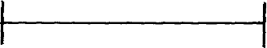Identify the following pattern makings.

B

A

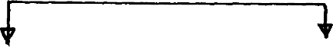E
C
D 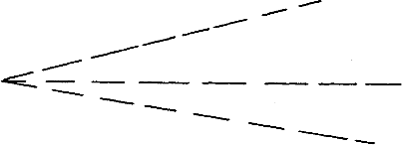

- Define the following terms. (5mks)
  - Consumer
………………………………………………………………………………………………………
………………………………………………………………………………………………………
  - Nutrition.
………………………………………………………………………………………………………
………………………………………………………………………………………………………
  - Food
………………………………………………………………………………………………………
………………………………………………………………………………………………………
  - Goods
………………………………………………………………………………………………………
………………………………………………………………………………………………………
  - Food nutrients.
………………………………………………………………………………………………………
………………………………………………………………………………………………………

- Differentiate between.
  - Informative and competitive advertising. (2mks)
………………………………………………………………………………………………………
………………………………………………………………………………………………………
………………………………………………………………………………………………………

  - Electronic media and print media. (2mks)
………………………………………………………………………………………………………
………………………………………………………………………………………………………
………………………………………………………………………………………………………

- List four equipments that are used fro drying garments. (2mks)
………………………………………………………………………………………………………
………………………………………………………………………………………………………

………………………………………………………………………………………………………
………………………………………………………………………………………………………

- Give four advantages of using ironing board instead of a table. (4mks)
………………………………………………………………………………………………………
………………………………………………………………………………………………………
………………………………………………………………………………………………………
………………………………………………………………………………………………………

- State five uses of fabric conditioner. (5mks)
………………………………………………………………………………………………………
………………………………………………………………………………………………………
………………………………………………………………………………………………………
………………………………………………………………………………………………………
………………………………………………………………………………………………………
………………………………………………………………………………………………………

- Identify effects of laundry processes on woolen fibres. (3mks)
………………………………………………………………………………………………………
………………………………………………………………………………………………………
………………………………………………………………………………………………………

- Give two reasons why French seam is commonly used on children garments. (2mks)
………………………………………………………………………………………………………
………………………………………………………………………………………………………

- Mention two uses of bleaches in the laundry work. (2mks)
………………………………………………………………………………………………………
………………………………………………………………………………………………………

FORM 2 MIDTERM 2 EXAMS


SMART-GRADE SERIES
MATHEMATICS
TIME: 2 HOURS

NAME……………………………………………………. ADM NO; …………………..

CLASS……………………………………………………… DATE……………………..

MATHEMATICS TIME: 2 ½ HOURS

INSTRUCTIONS TO CANDIDATES:
- Write your name, admission number and school in the spaces provided above.
- This paper consists of two sections; I and II
- Answer all the questions in section I and any five questions in section II in the spaces provided.
- All working must be clearly shown in the spaces provided.
- Electronic calculators and KNEC mathematical tables may be used.

FOR EXAMINERS’ USE ONLY:
Section I

Questions | 1 | 2 | 3 | 4 | 5 | 6 | 7 | 8 | 9 | 10 | 11 | 12 | 13 | 14 | 15 | 16 | TOTAL
Marks

Section II
Questions | 17 | 18 | 19 | 20 | 21 | 22 | 23 | 24 | TOTAL
Marks

GRAND TOTAL

SECTION I (50 MARKS)

Answer all the questions in this section in the space provided.
- Without using logarithm tables or a calculator evaluate.
0.015 + 0. 45 ÷1.5
4.9 x O.2 + 0.07 giving the answer in decimal form. (3mks)

- The size of an interior angle of a regular polygon is 156o. Find the number of sides of the polygon. (2mks)

- Factors the expression a² – b² (1mk)

Hence find the exact value of 63.72 – 36.32 (2mks)

(2mks)
4. Arrange the following fractions in ascending order | 7, | 5 , 3, | 9, 1
 | 24 | 16 8 | 32 4

- A clock loses 6 minutes in every 24hours. If it is showing the correct time at mid- day on Monday. What is the correct time on Thursday when the clock shows 6.00p.m (3mks)

- Without using a calculator evaluate 2 ¼ + ¾ ÷ 5/₆ of 2 ²/₅ leaving the answer as a
17/₁₀ fraction in its simplest form
(4mks)

- Use logarithms to evaluate 8.072 X (0.74 32) ½ (3mks)
(0.824)2

8. Evaluate 64– ½ X 27000 ⅔ (4mks)
2-4 X 30 X 52

9 In the figure below line AB is parallel to line CD; angle BAD = 40o and Line DE = DF

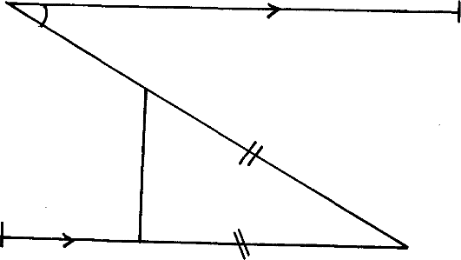
A 40o B
E

C F D

Calculate the size of angle CFE (3mks)

- In the figure below O, is the centre of the circle and angle OAB = 30o
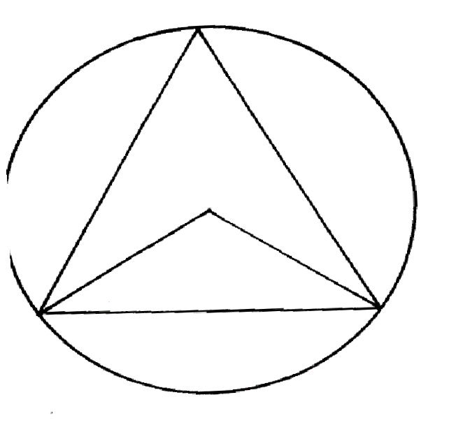
C
O
B
30º
A
Calculate the size of angle ACB. (3mks)

- Calculate the perimeter of a rhombus whose diagonals are 12cm and 5 cm (4mks)

12.A metal hemisphere of radius 12cm is melted down and recast into the shape of a cone of
base radius 6cm. find the perpendicular height of the cone. (4mks)

- The coordinates of the line AB are A ( 4,6) and B ( 12,10) . Find the equation of a perpendicular line to line AB, passing through the mid-point of the line AB (3mks)

- Two similar jugs have capacities 0.25 litres and 2 litres respectively. If the circumference of the smaller jug is 5.8cm calculate the circumference of the larger jug. (3mks)

- Find the range of values of x which statisfy the inequality. 2x +1< 11< 6x – 1.
Illustrate your answer on the number line (4mks)

- The figure below represents s a hexagonal prism, whose height is 20cm. the cross – section of the prism is a regular hexagon of side 5 cm. Calculate the volume of the prism; give your answer to 2dp (4mks)
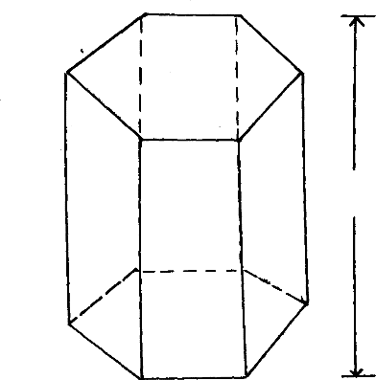
20cm
5cm

SECTION II ( 50 MARKS)

Answer only five questions in this section in the space provided.
- The figure below shows part of a circle centre O, radius 6cm; the Length of the chord AB is 9 cm
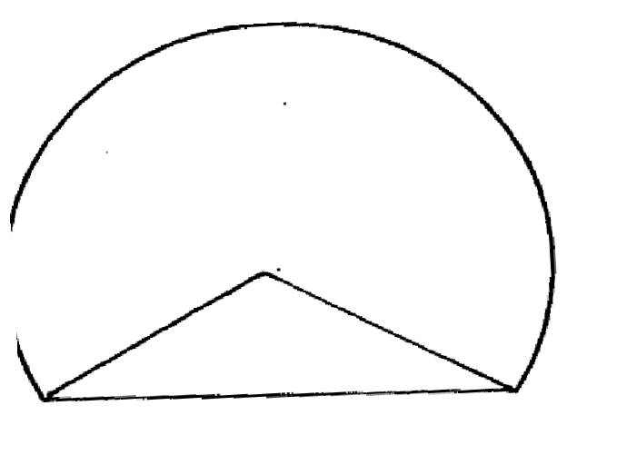
O
6cm
A
9cm
B
  - Calculate the area of the major segment (7mks)

  - Given that the sides of triangle are 7cm, 9cm and 11cm.Calculate the area of the triangle.
(3mks)

18 a) By choosing any three suitable pairs of values of x and y complete the table of values for each function.
(i) x + 3y = 15 (2mks)
x
y

2
x
y

  - x – y = 4 3
(2mks)

- Using the grid provided , and on the same axes, draw the lines x + 3y = 15 and x – y = 4(4mks)
2 3

- Use your graph to solve the equations x + 3y = 15 (2mks)
2
x – y = 4 3

- The ratio of Kipto’s Salary to Mary’s is 5:3. Kipto’s salary rose by 12% to Kshs. 22400. Mary’s salary was also raised by x%. The total of their new salaries was Kshs. 36 200.
  - Calculate
- Kipto’s Salary before the increase (2mks)

- Mary’s Salary before the increase. (2mks)

- Determine Mary’s salary after the increase. (1mk)

- What was the percentage increase in Mary’s Salary. (2mks)

- Determine the new ratio of their salaries. (2mks)

- Calculate the combined percentage increases for both of them. (1mk)

- The mean mass of 5 boys is 54.4 kg. Three boys of masses 52kg, 55.1 kg and 57.5 kg join the five. Calculate the mean mass of the 8 boys (3mks)

- The table below shows the distribution of ages of workers in certain organization.

Age (Years ) | Number of Workers
20 – 24  25 – 29  30 – 34  35 -39  40 - 44 | 5  10  18  15  12
  - State the modal class (1mk)

  - Calculate the mean age (3mks)

  - Calculate the median age (3mks)

- a) A solid sphere of radius 8.4cm is dropped into a cylinder of radius 12cm and containing water upto a height of 10cm.
Determine the new height of water in the cylinder (6mks)

- If the mass of the sphere is 100g; determine
  - Density of the solid. (2mks)

  - Volume of similar solid which is irregular given that its mass is 800g; correct to the nearest cm3. (2mks)

- If x + y = 3 and x² + y² = 29. Determine the values of
- x² + 2xy + y² (1mk)

- 2xy (1mk)

- x² – 2xy + y² (1mk)

- x- y (2mks)

- Find the values of x and y (3mks)

- If x = -2 is a root of x² + kx + 8 = 0 , find the other root. (2mks)

- a) Two observers, A and B 500m a part observe a kite in the same vertical plane and from the same side of it. The angles of elevation of the Kite are 30o and 20o respectively. Find how high, the Kite was from the observers. (6mks)

Solve the equation cos x = sin 5x (2mks)

- In the right angle triangle below. Find the length of AB in 2d.p (2mks)

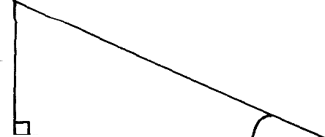C

4 cm

B x

35º
A

- A rectangle has a diagonal of 15.2cm. The diagonal makes an angle of 28o with the shorter side of the rectangle
- Calculate
  - The Length and width of the rectangle. (4mks)

  - The are of the rectangle. (2mks)

- A triangular plot has two equal sides. The two equal sides meet at an angle of 40o. The area of the plot is 128.56m2. Calculate the lengths of the sides of the plot. (4mks)

THE END

For Marking Schemes, Contact Mr Isaboke

0746-222-000/0742-999-000

Mwalimu Consultancy Ltd

FOR THE FOLLOWING;
  - ONLINE TUITION
  - REVISION NOTES
  - SCHEMES OF WORK
  - SETBOOKS VIDEOS
  - TERMLY EXAMS
  - QUICK REVISION KITS
  - KCSE TOPICALS
  - KCSE PREMOCKS
  - TOP SCHOOLS PREMOCKS
  - JOINT PREMOCKS
  - KCSE MOCKS
  - TOP SCHOOLS MOCKS
  - JOINT MOCKS
  - KCSE POSTMOCKS
  - TOP SCHOOLS PREDICTIONS
  - KCSE PREDICTIONS
  - KCSE REVEALED SETS

Call/Text/WhatsApp

0746-222-000

0742-999-000

mwalimuconsultancy@gmail.com

This is a Copyright Property of Mwalimu Consultancy

Powered By Mr Isaboke

